End to End Weather chatbot using Google Dialogflow and AWS CICD Deployment

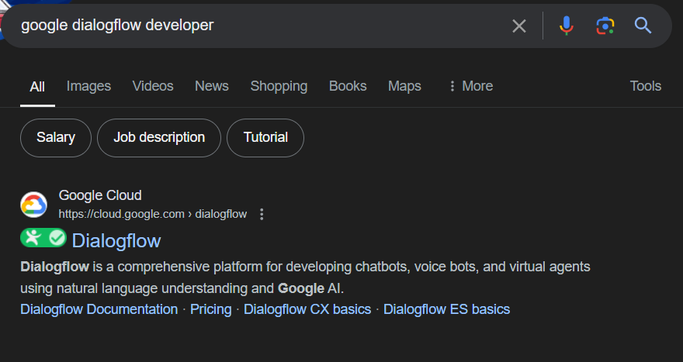

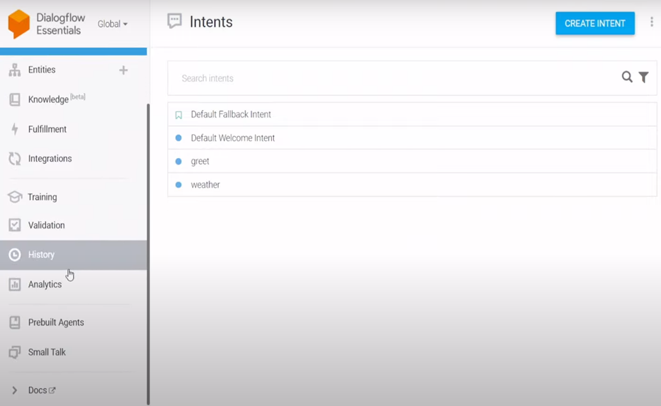

Create an agent

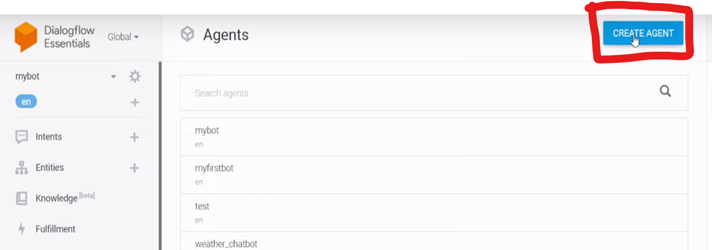

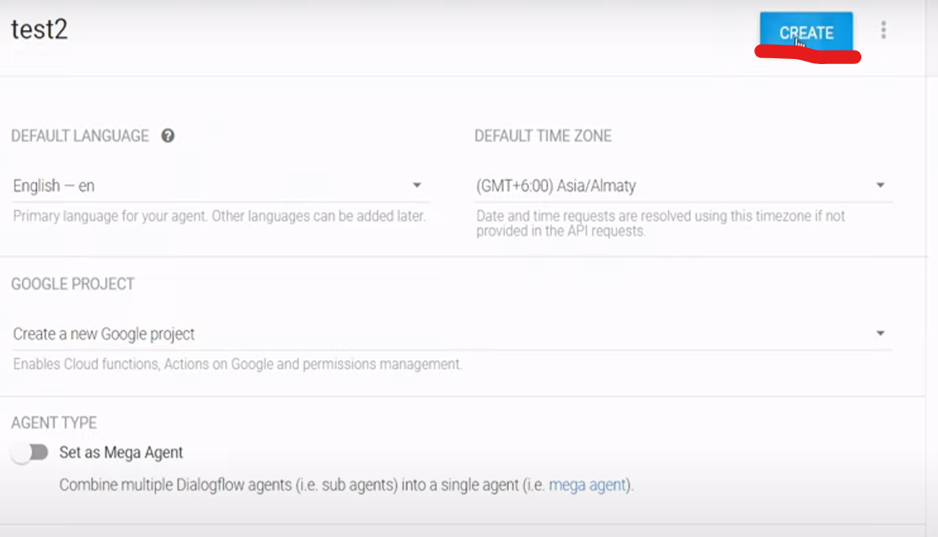

Now I need to create an intent, by default google provided you the default intents and now iam going to create an new custom intent.

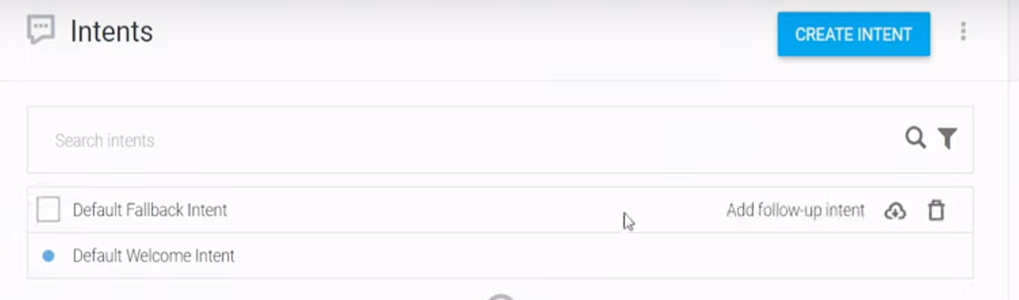

Click create intent

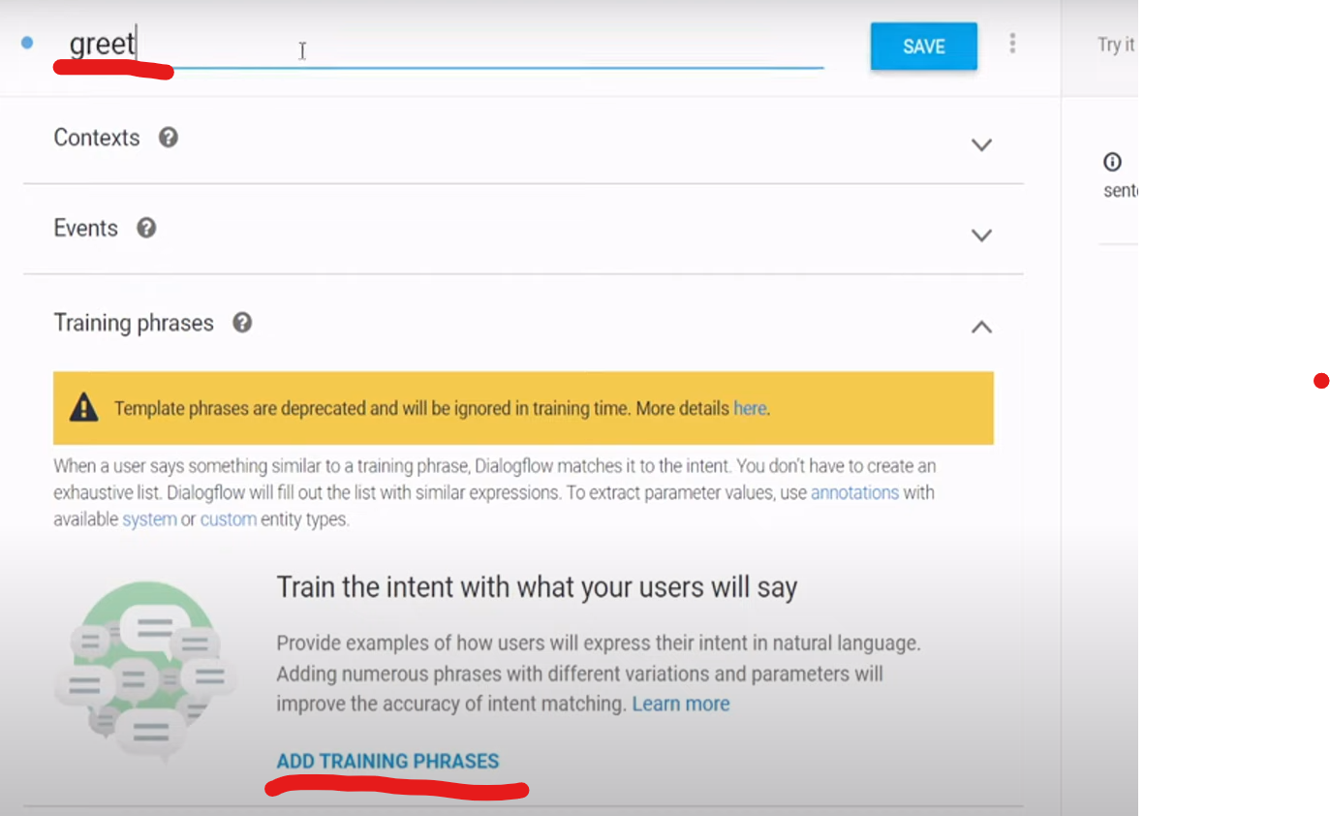

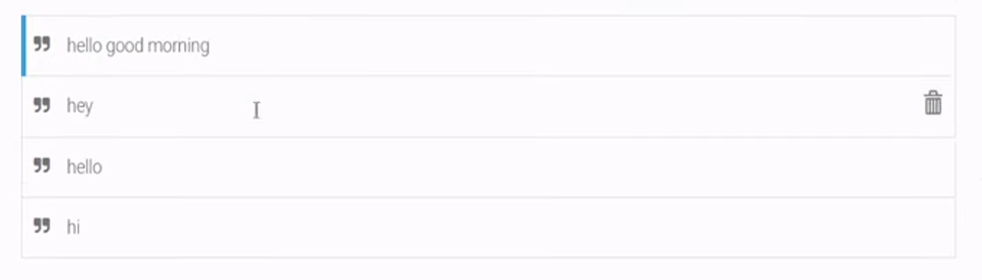

Now add the responses

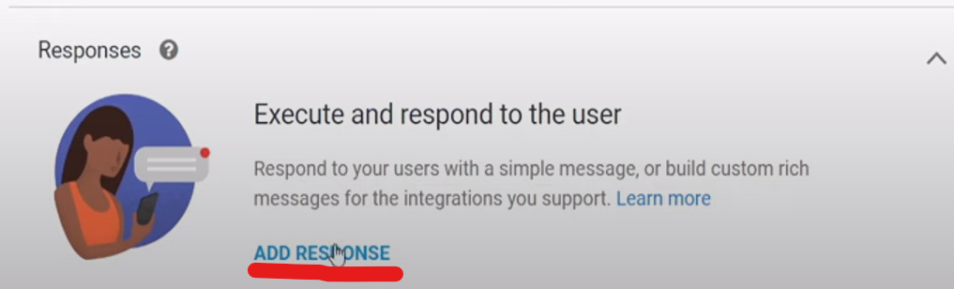

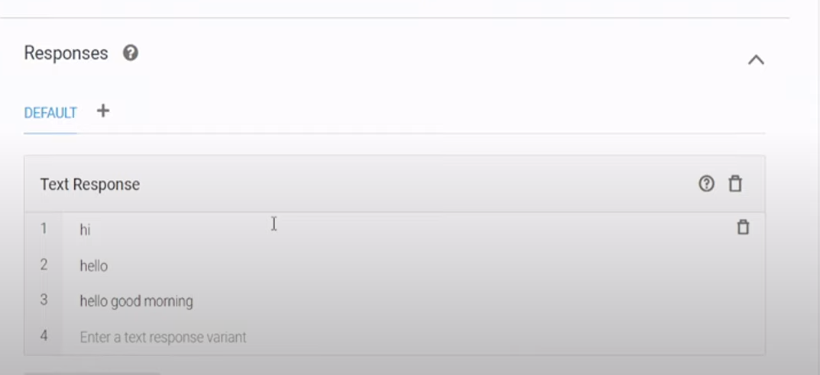



Now test

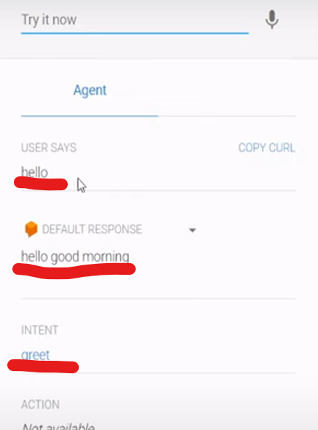

It is not a rule based chatbot it is a AI based chatbot

Intent will see later

Knowledge base – Why knowledge base? Each and every intent we cannot write here we can directly dumb in to the google dialog flow

How to enable the knowledge base feature

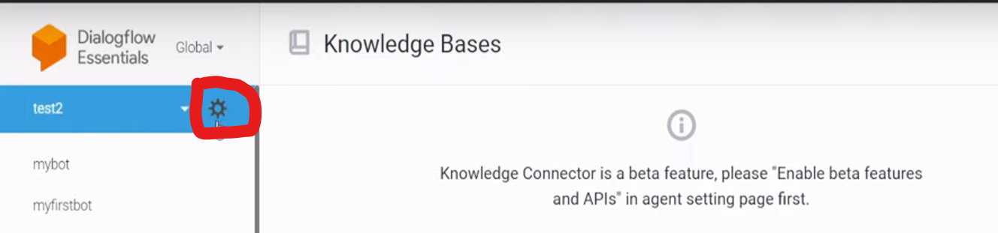

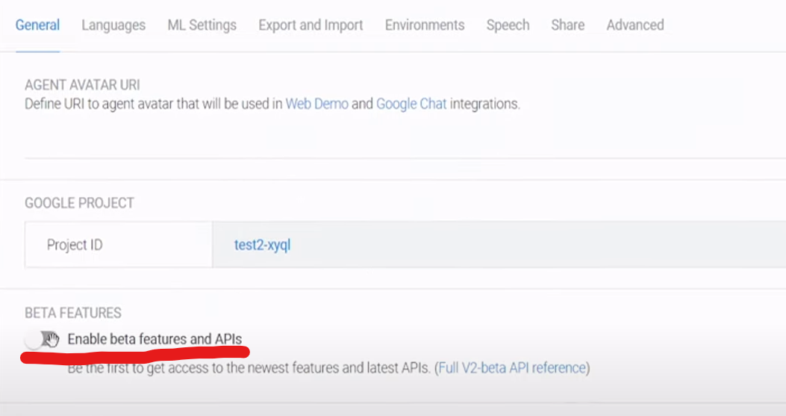

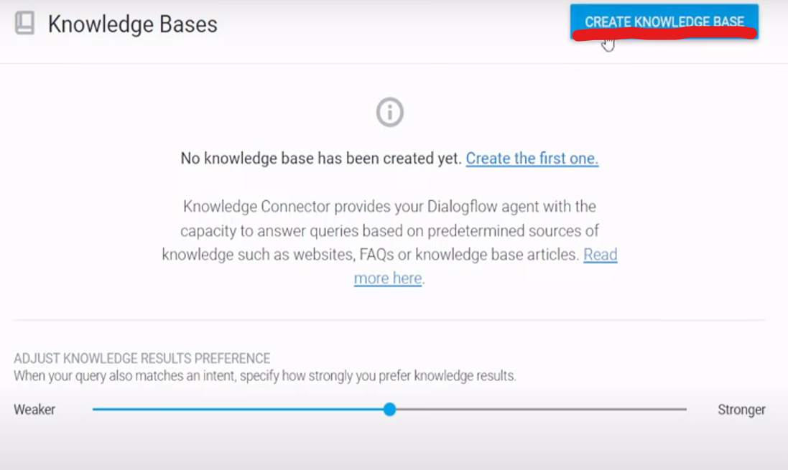

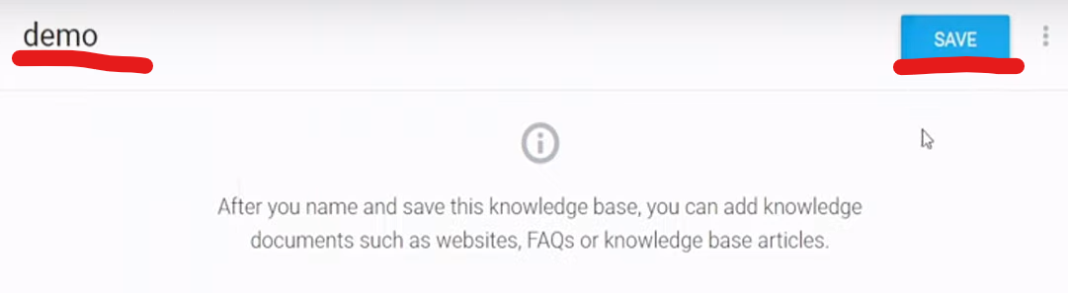

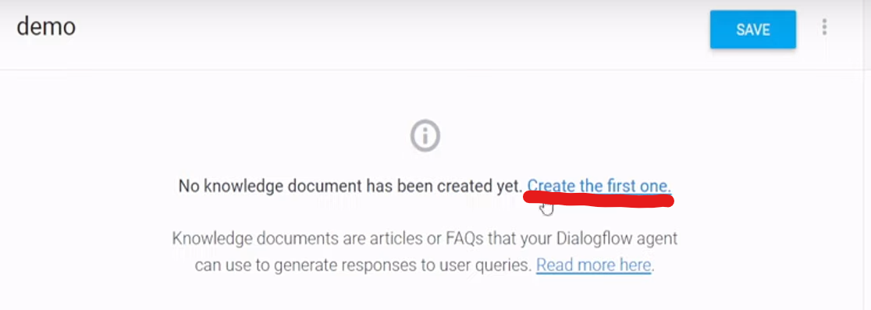

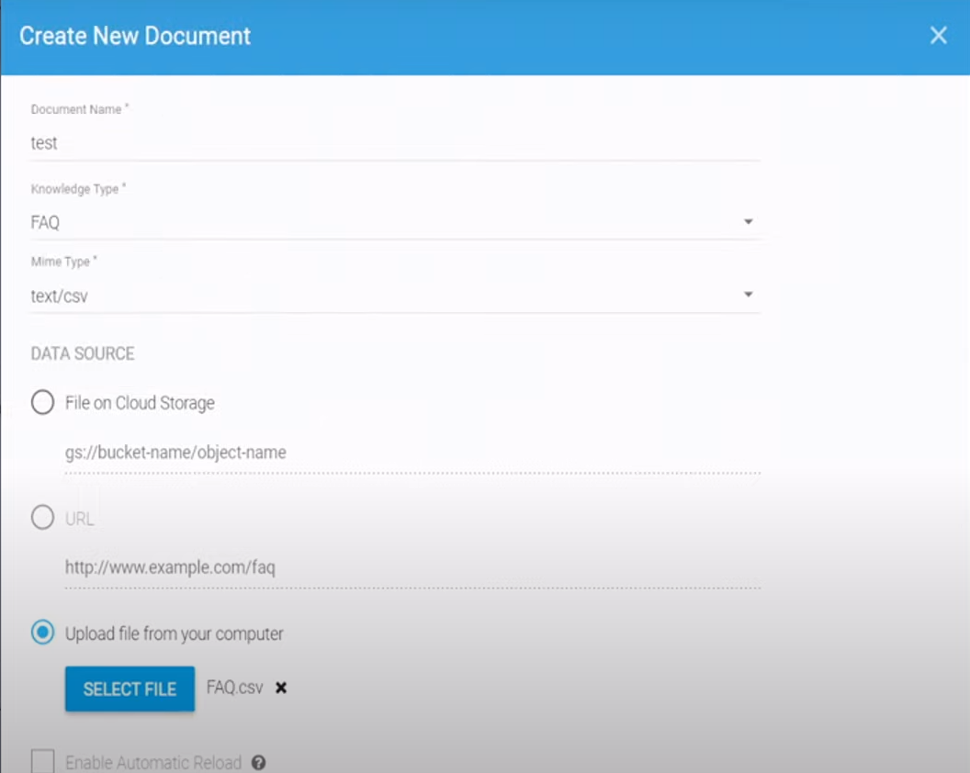

Click create

Sample FAQ document

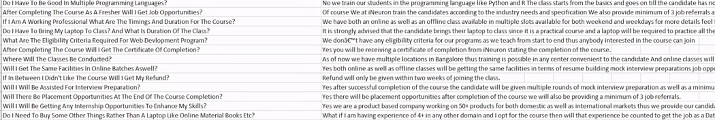

Make sure when you create the FAQ document avoid the special characters inside the document, it having some text with special characters just terminate those text’s from the document.

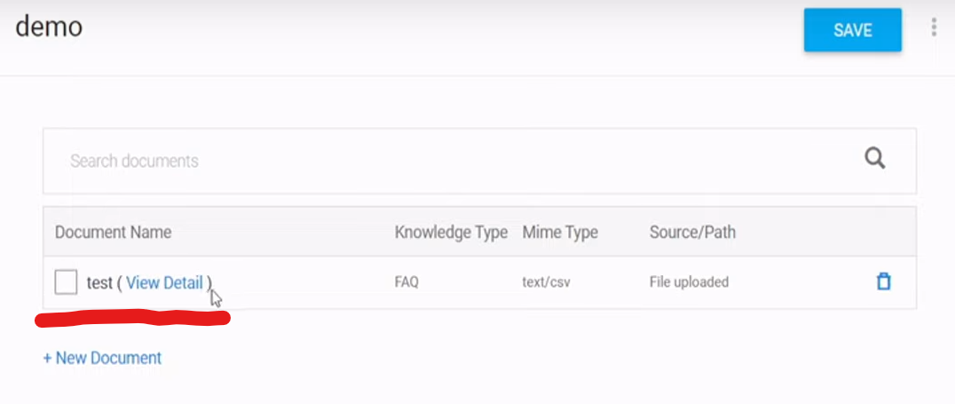

For enabling the knowledge base

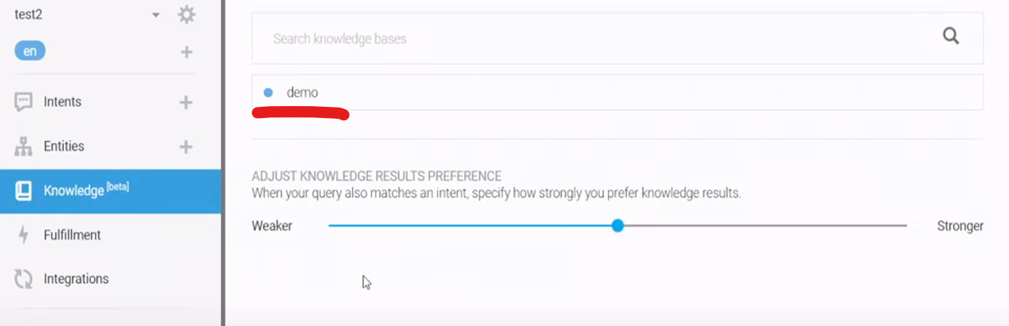

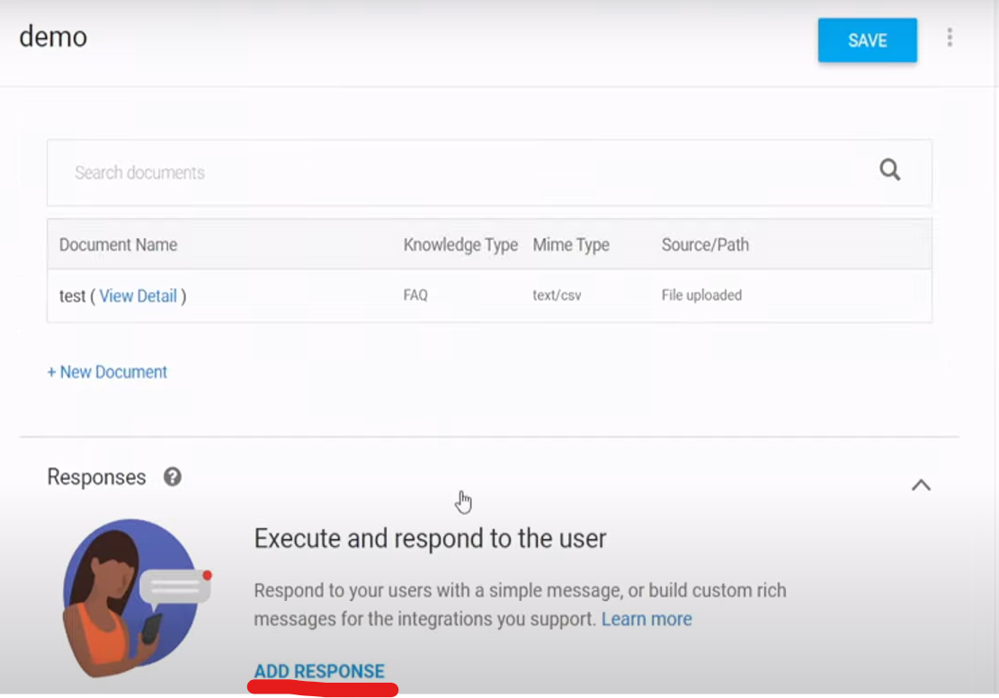

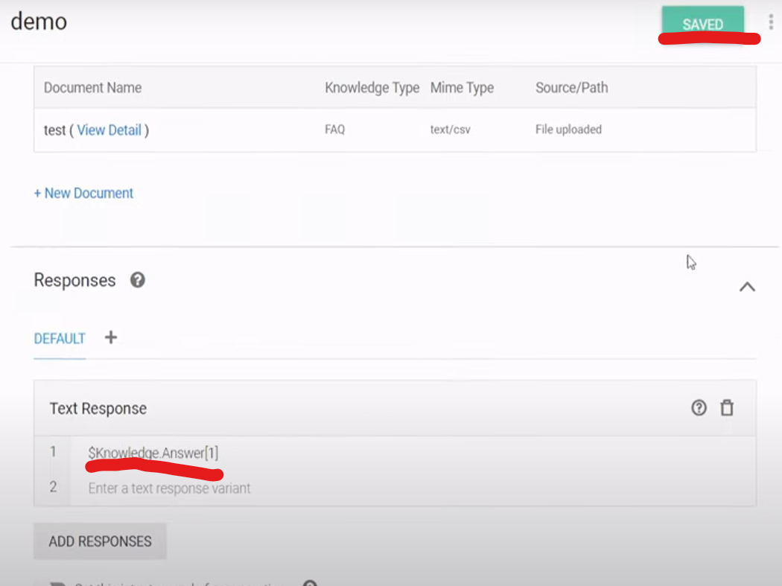

Test

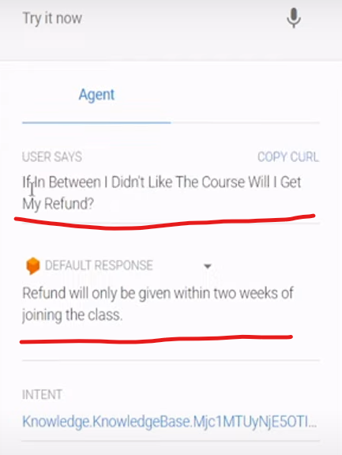

Now we are going to create an agent specific to our use case.

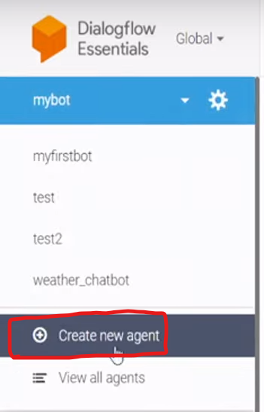

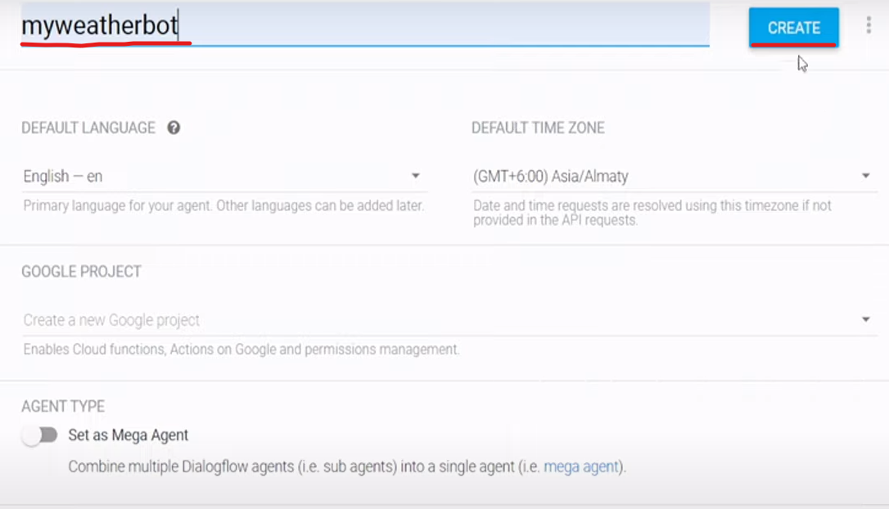

Now we have to create an intent

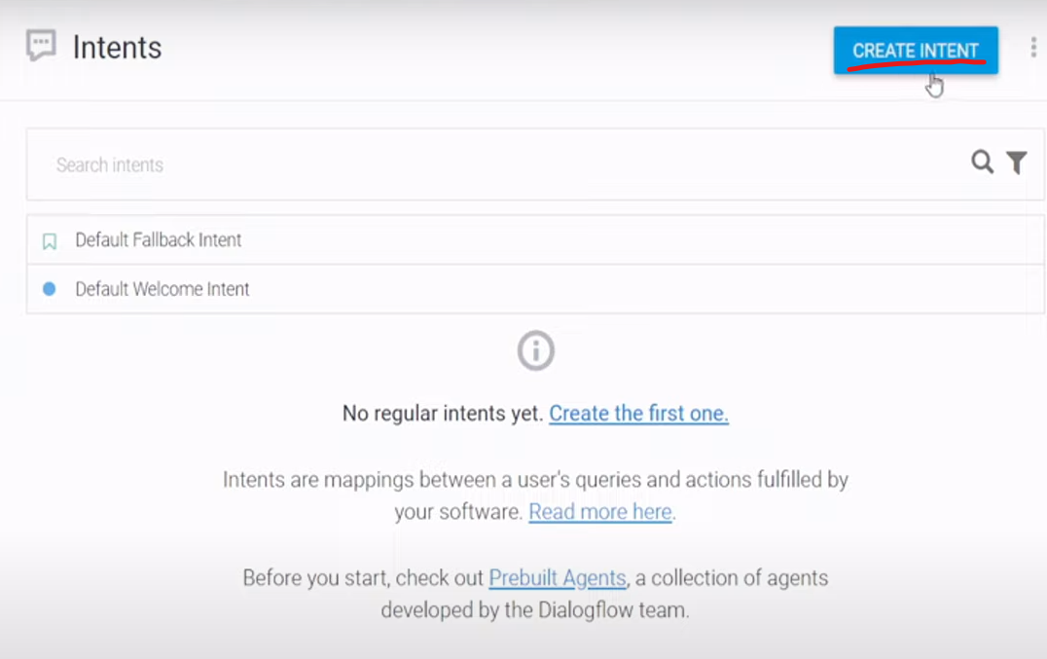

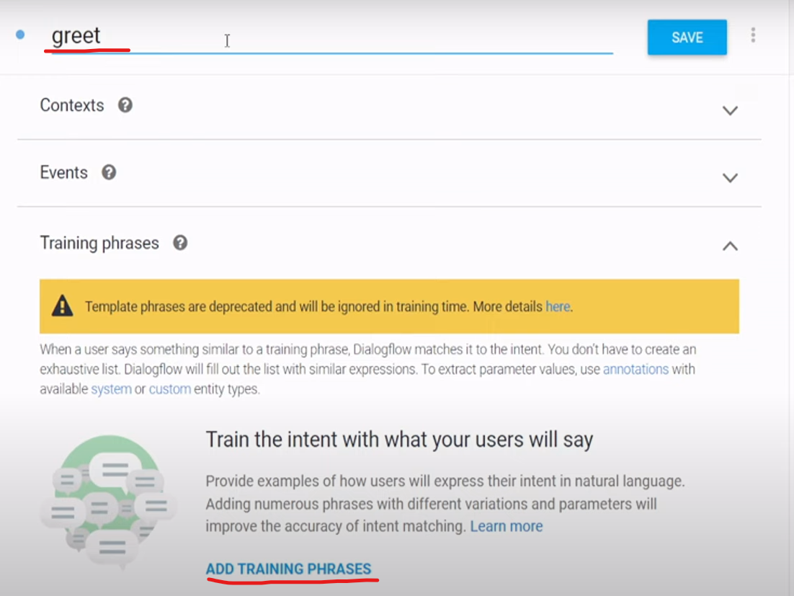

Add training phrases and corresponding responses base on the greet intent.

Create a new intent based on the weather

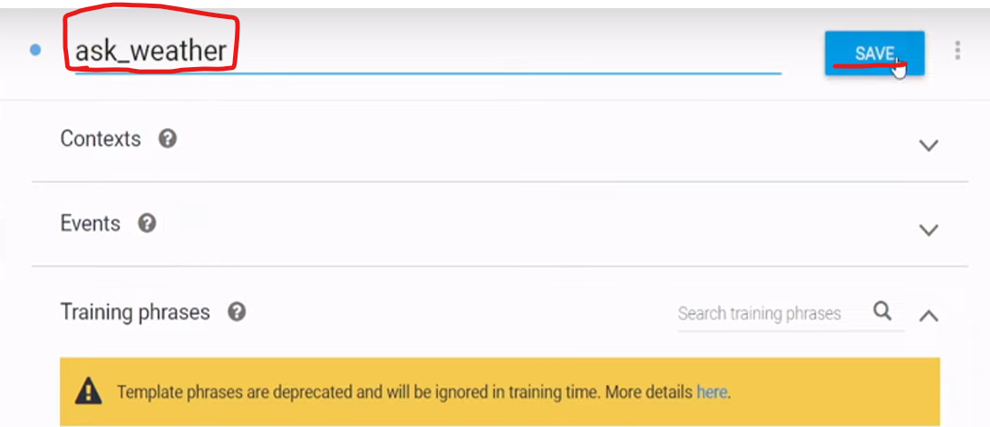

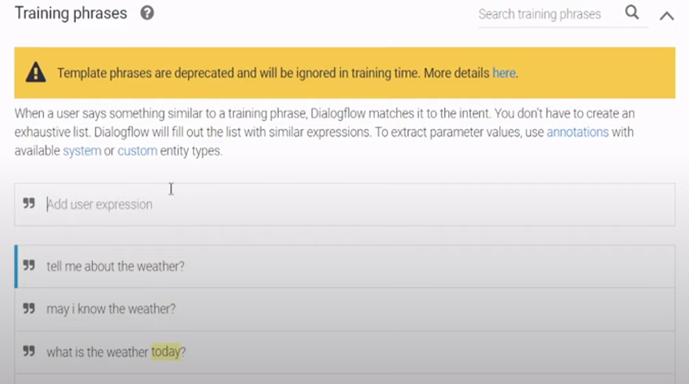

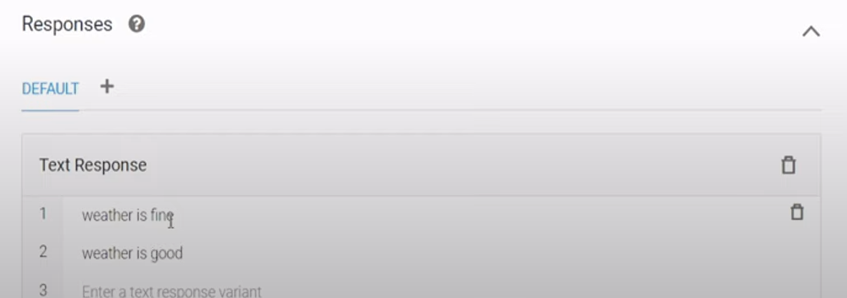

Save the expression and their response.



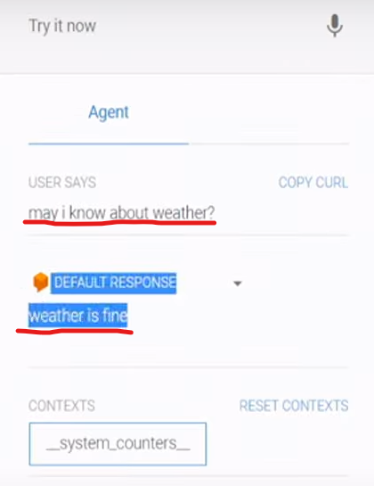

Create a knowledgebase

Inorder to use the knowledgebase we need to enable the beta feature and save it.

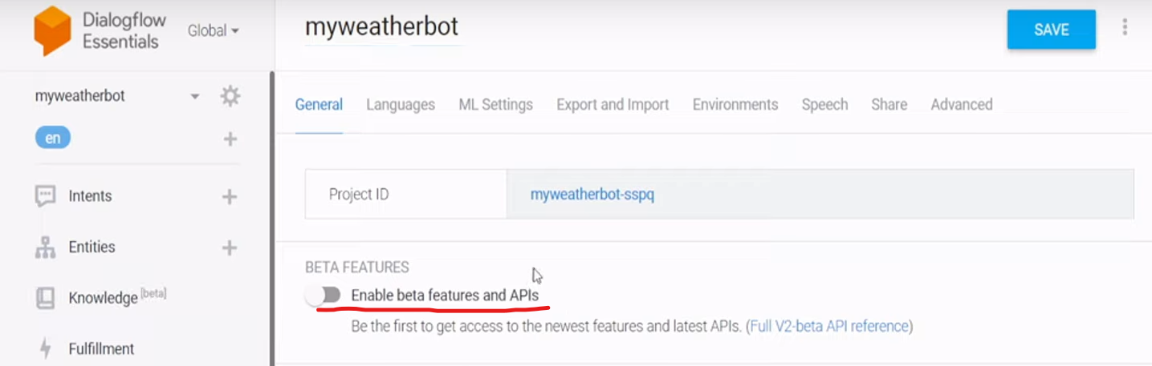

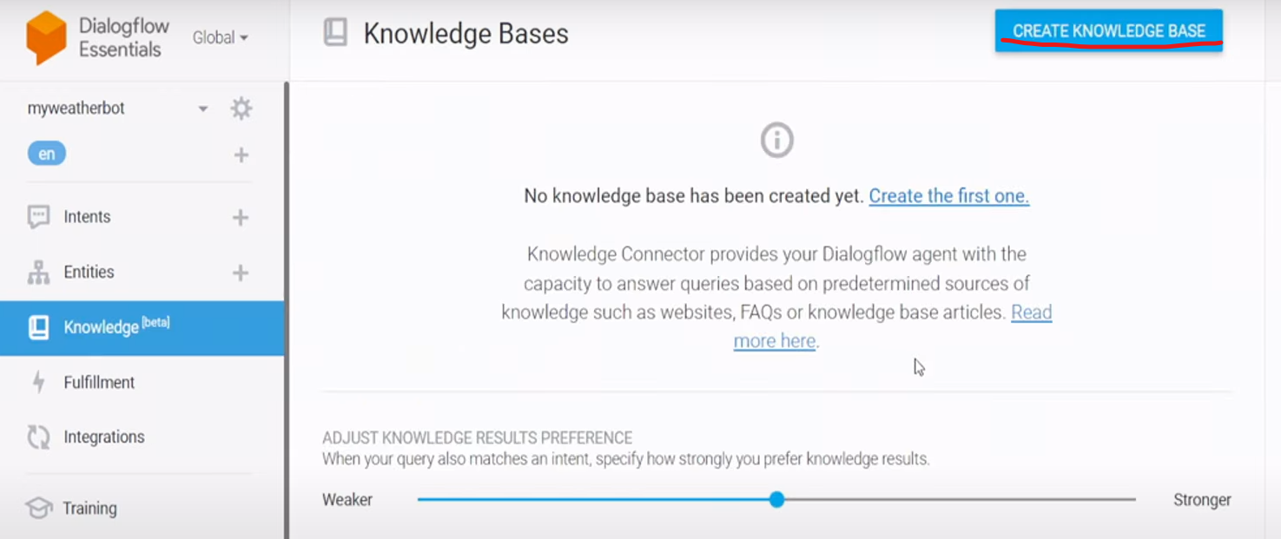



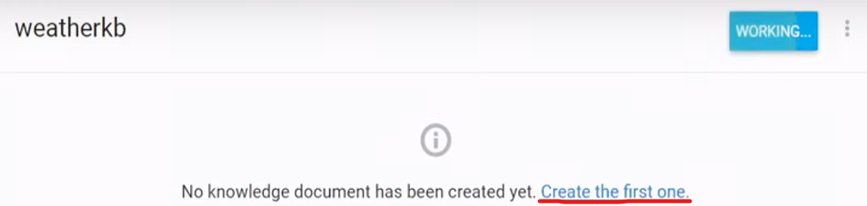

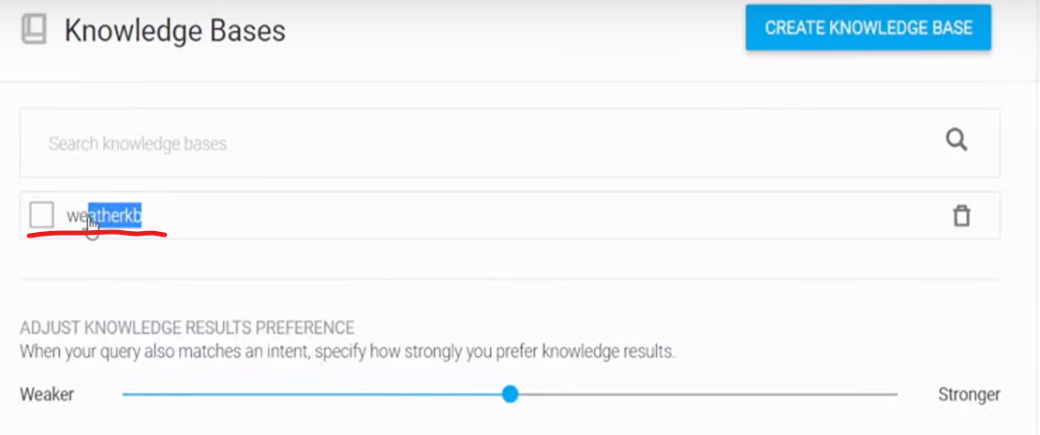

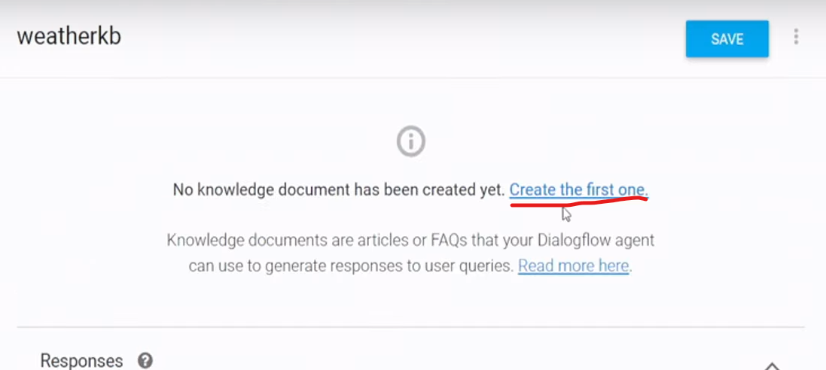

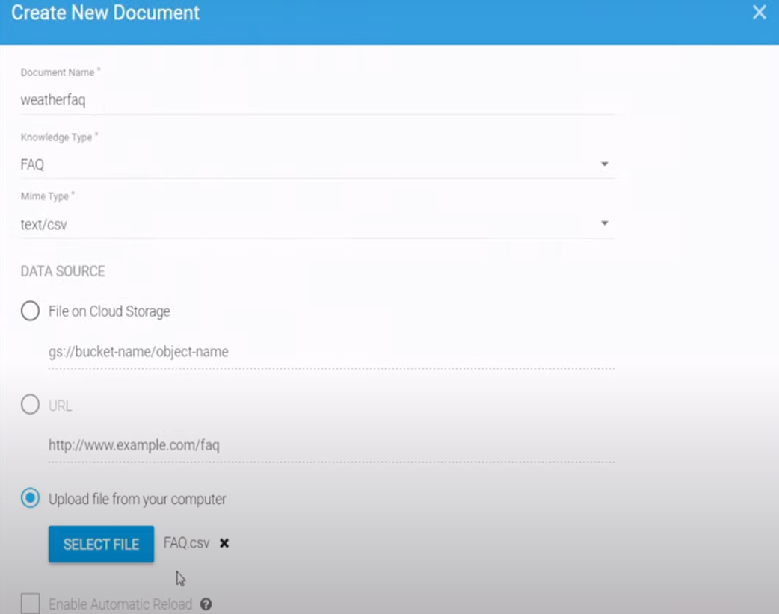

Click create

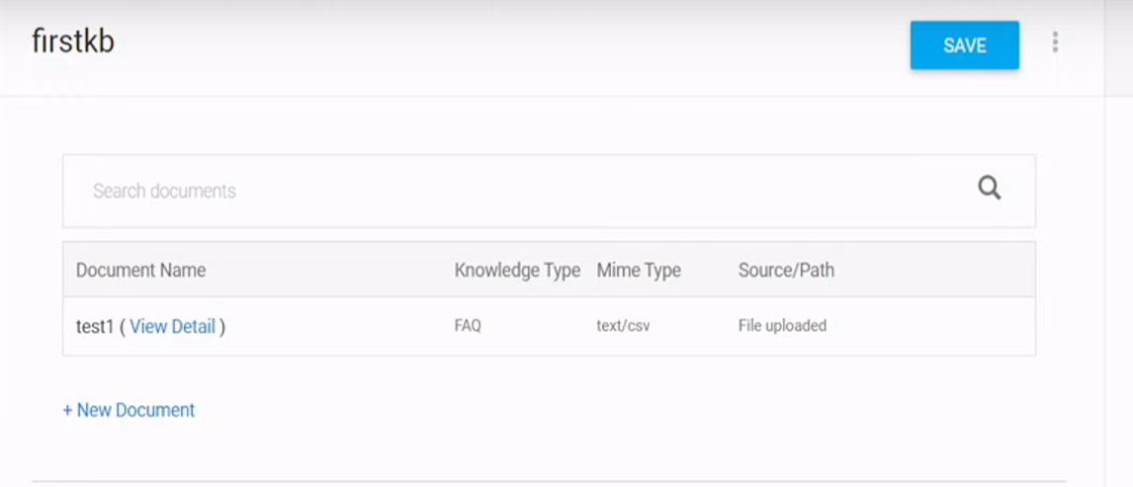

Test

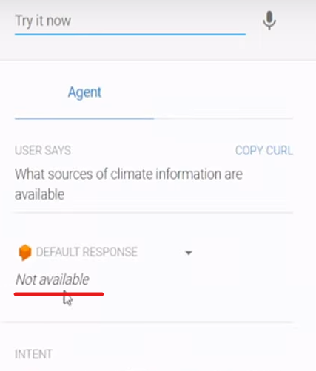

It is not available because in the response automatically considering this response

Go back and click response

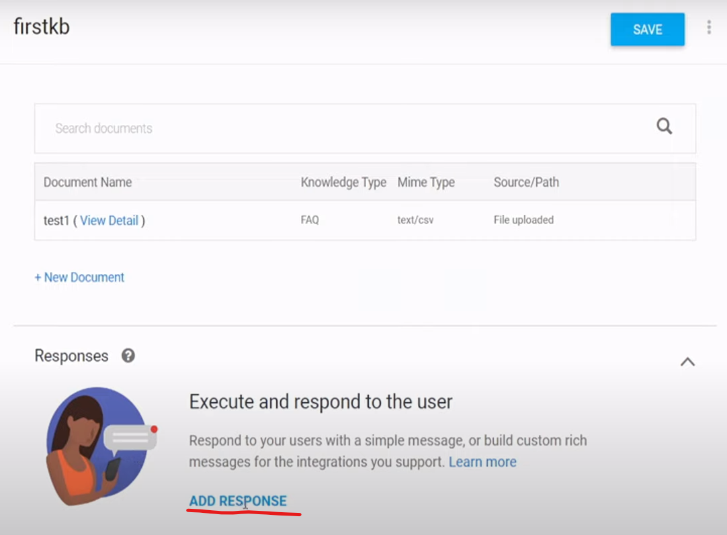

Just save it.

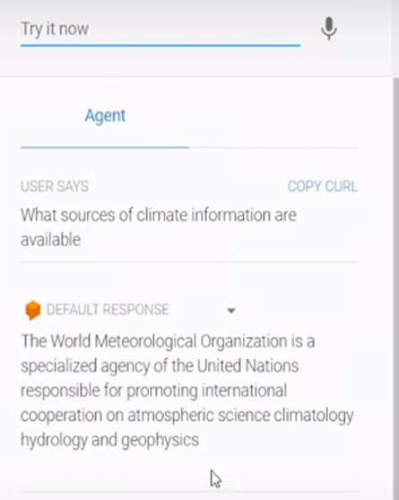

Entity

Inorder to get the precise answer we need to create an entity

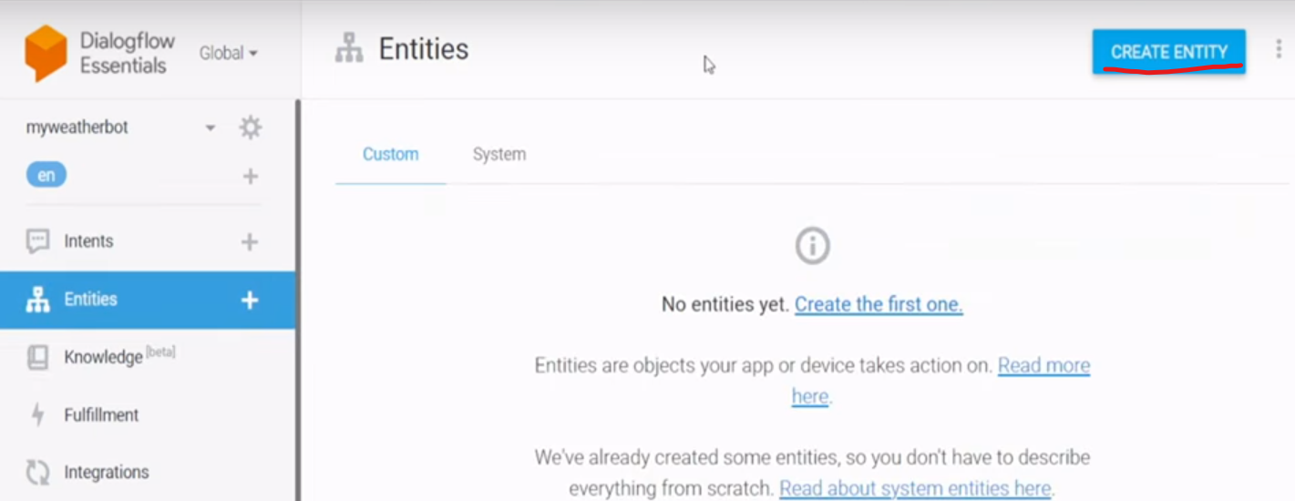

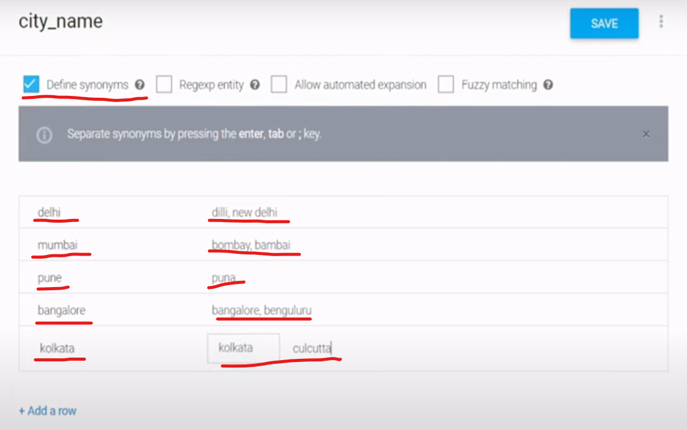

Save the entity and go back to the intent

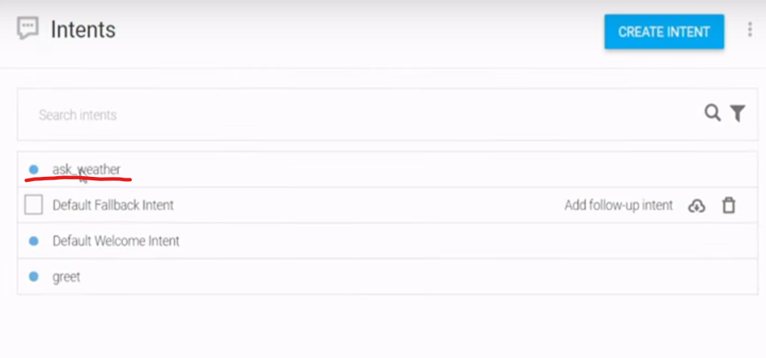

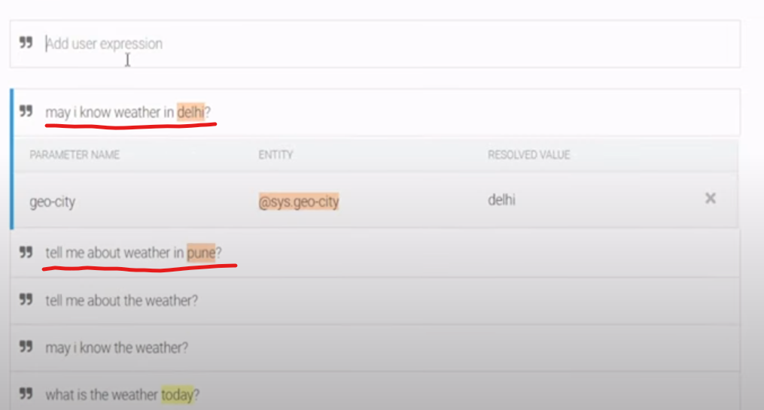

By default the goe_city will be selected but we need to select the intent that we have created for every cities that we mentioned in the expression

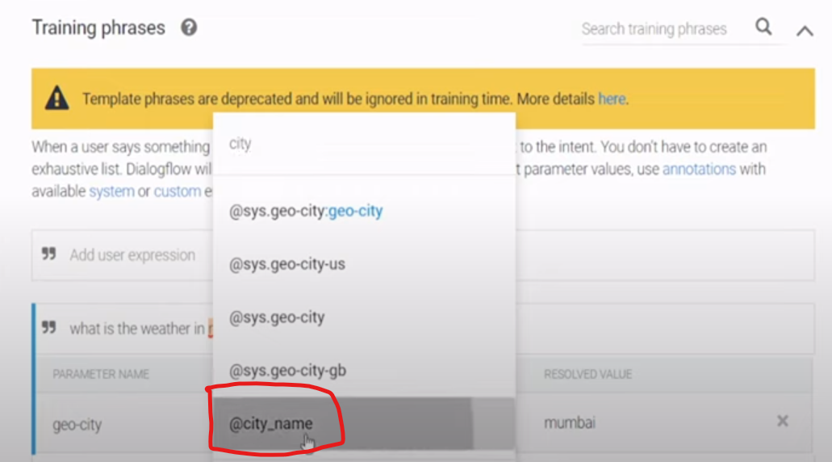

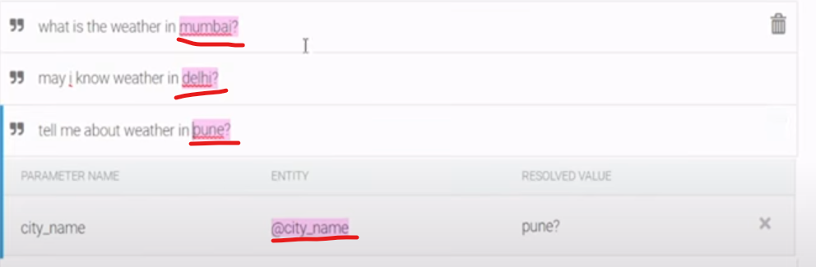

Then save the intent

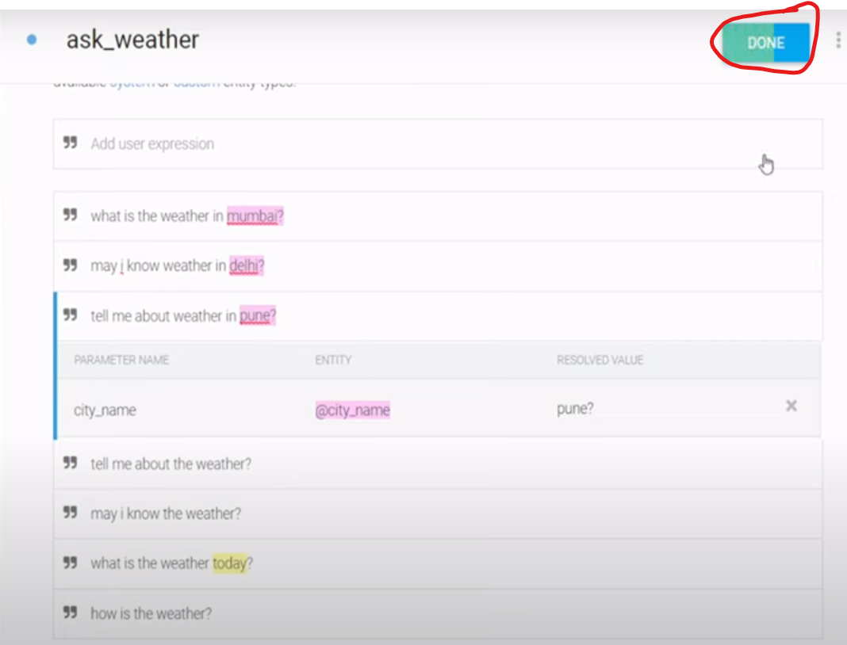

Make city_name as mandatory to prompt the user to give the city name to get a precise answer.

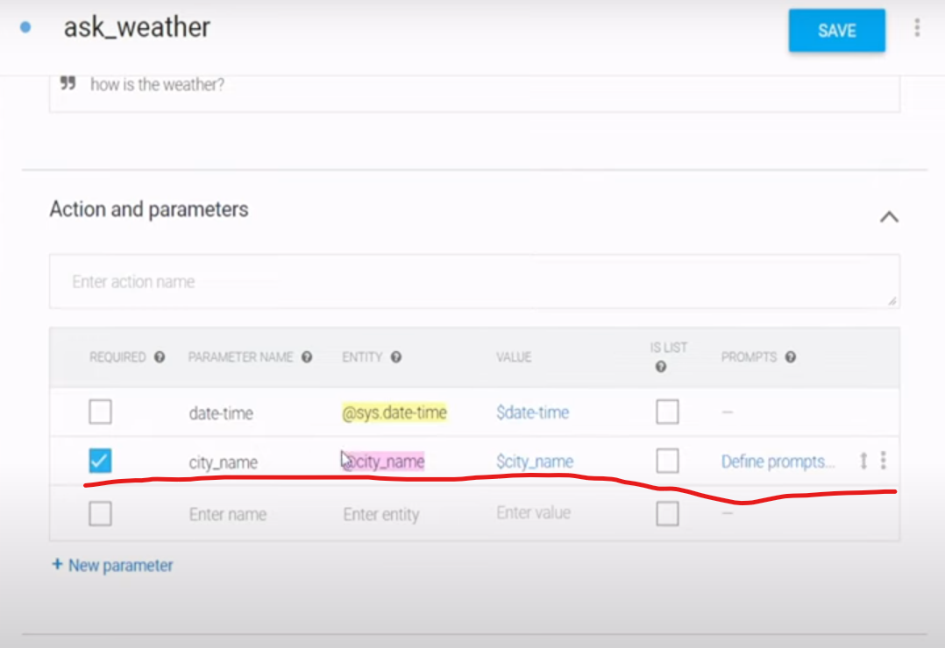

Click define prompts

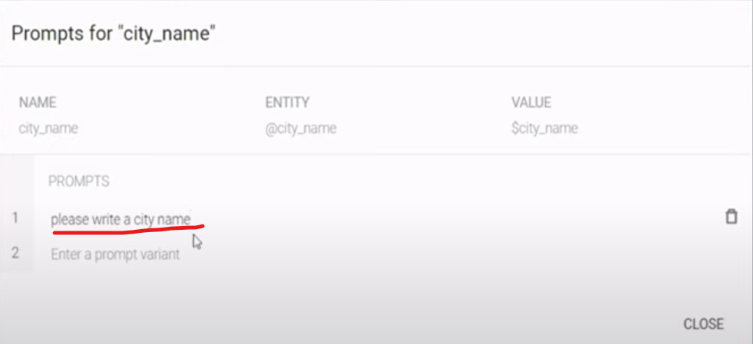

Click save

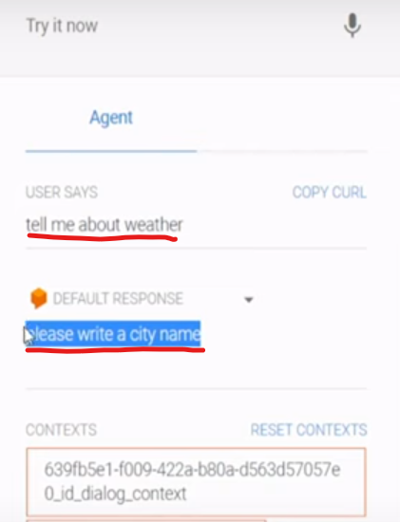

Create a web application using FLASK

First create a github repo

Create a new folder and open the folder in VSCode

Initialize the git – git init

Add the file git add .

Commit – git commit -m “first_commit”

Select the main branch, add remote origin and push the code to the repo

Create an environment : conda create -p “envname” python=3.x -y

Activate the env : source activate “envname”

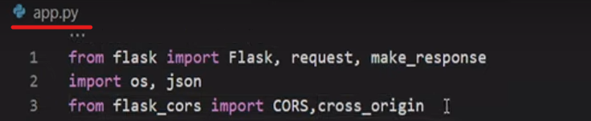

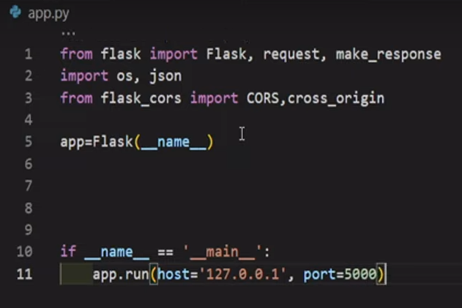

Create a route

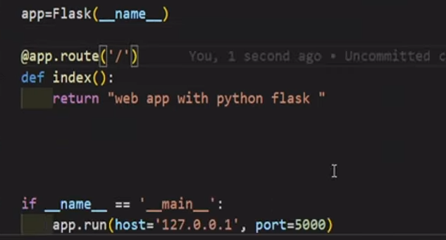

Run to check the route is working fine or not

Command : python app.py

It gives you an error because packages are not installed in our environment. So we need to install the environment first.

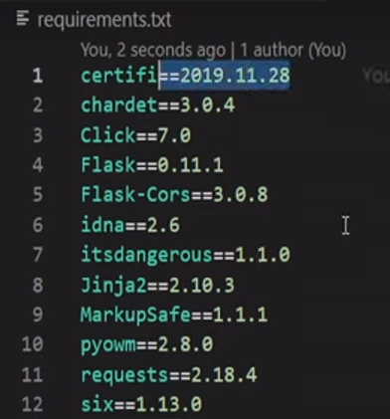

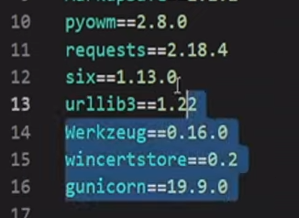

Command : pip install -r requirements.txt

Once the packages was installed now run the file : app.py

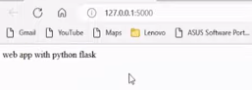

For getting the precise answer I have to connect the google dialogflow with Flask API and the Flask api will take care or responsible to gather the accurate weather information about the particular City.

Atlast you will be able to see the link like “diagnostic info”

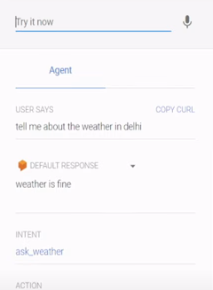

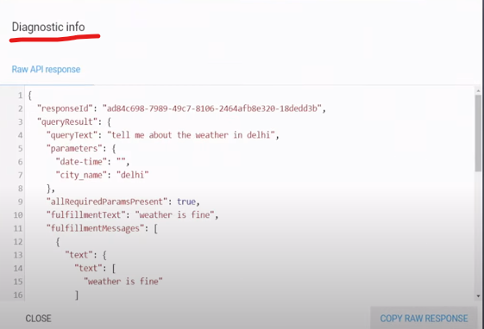

Copy all (request structure) open the JSON viewer

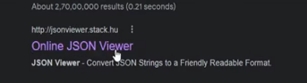

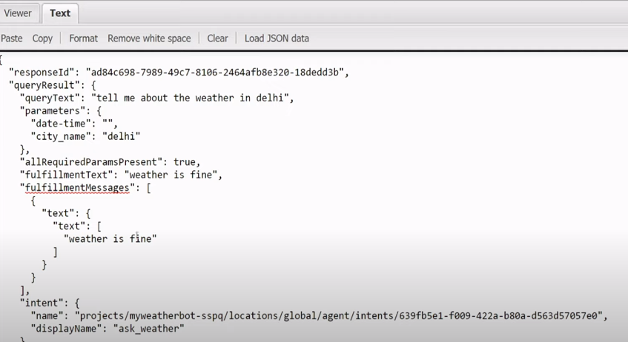

Copy the entire JSON text and paste inside the postman – it is software to hit the API’s

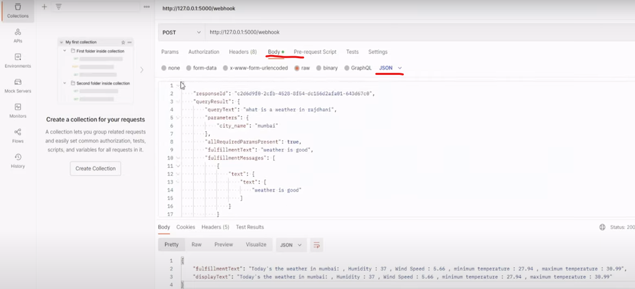

Project structure

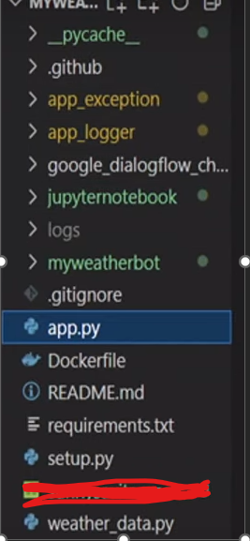

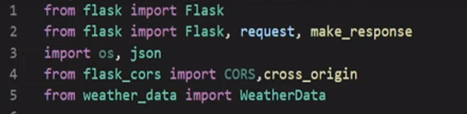

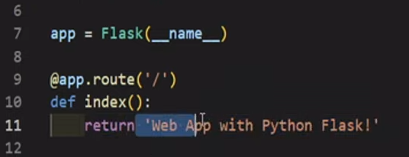

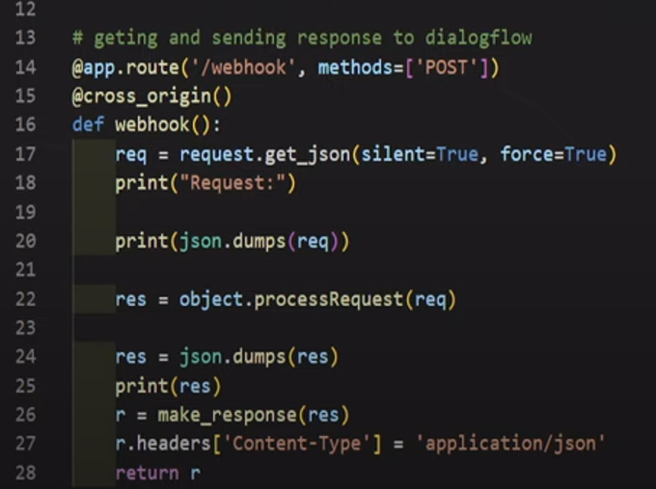

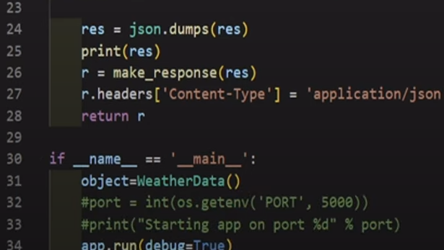

Weatherdata.py

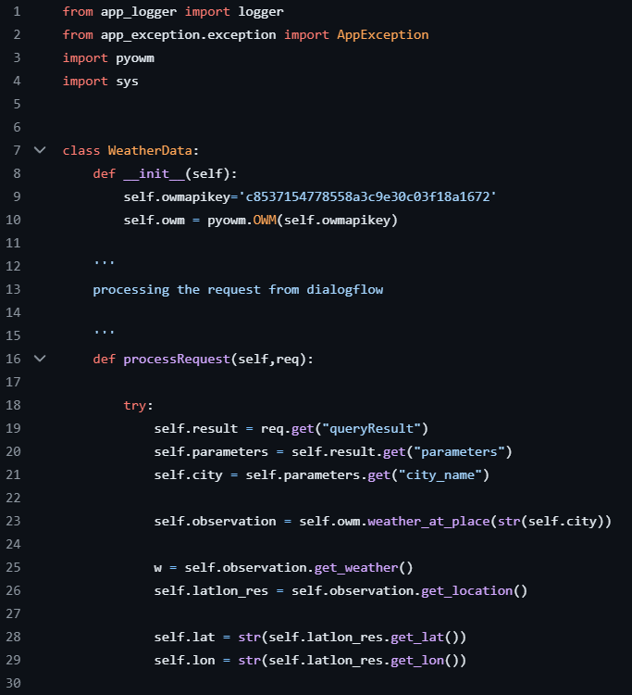

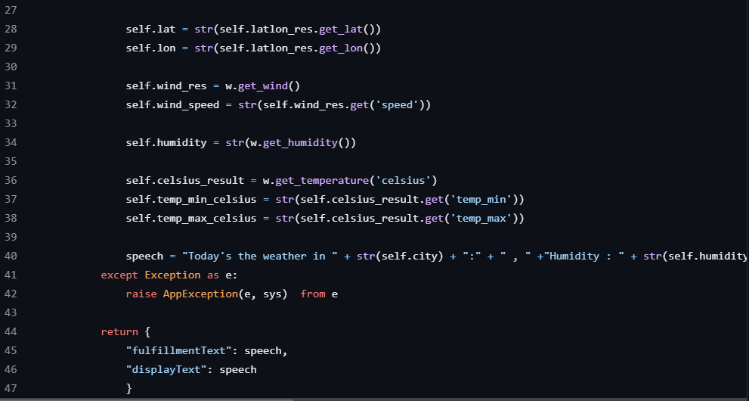

Open weathermap API (OWM) – To get the live weather of the particular city

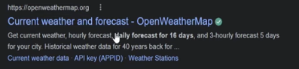

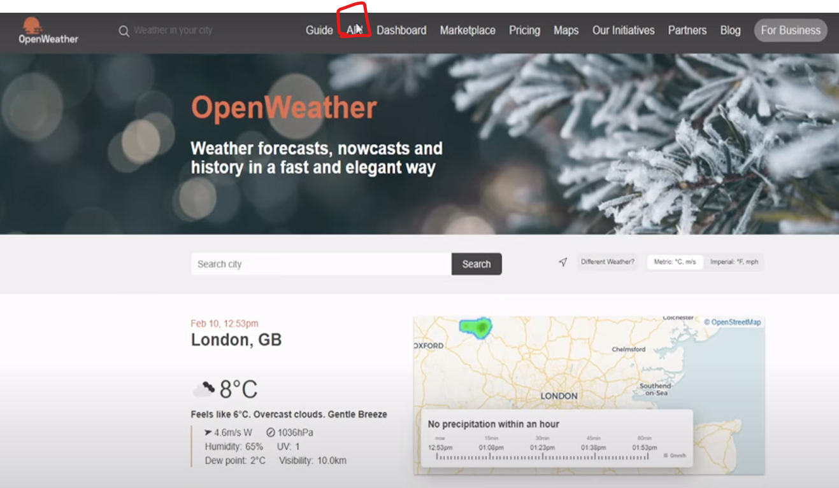

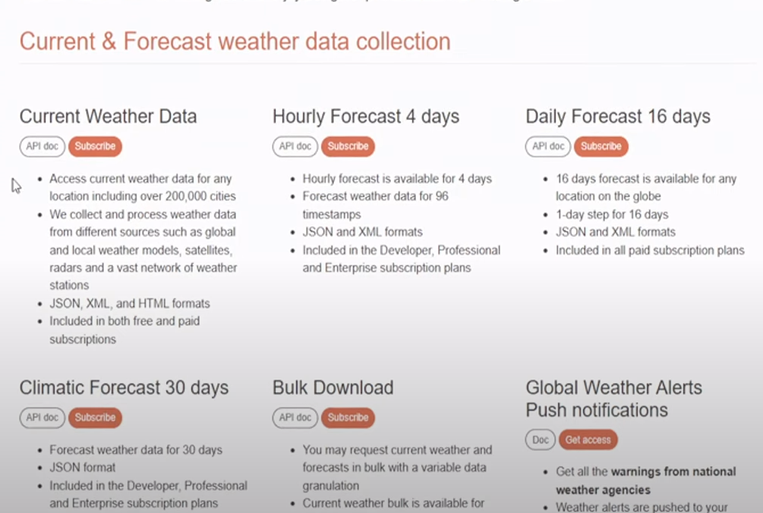

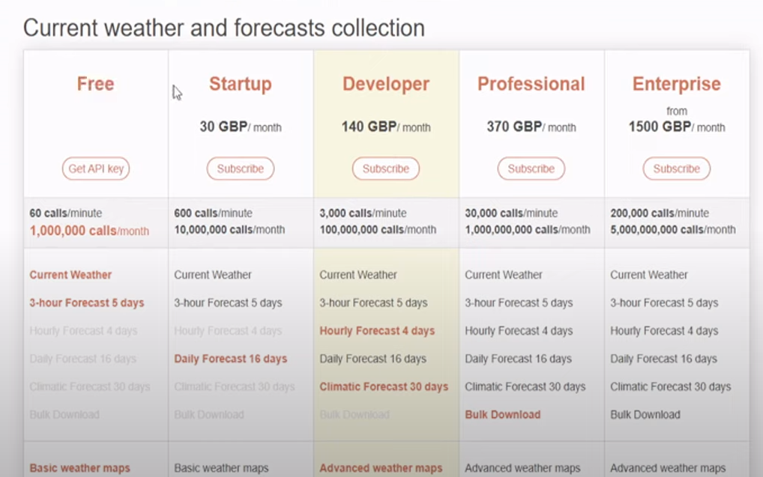

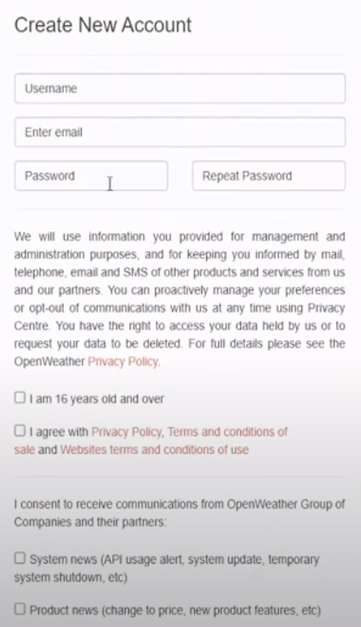

Once you done the subscription then you will get the API Key.

OWM pypy package

Run app.py file the hom page will open in the browser

Now we can hit the API from postman

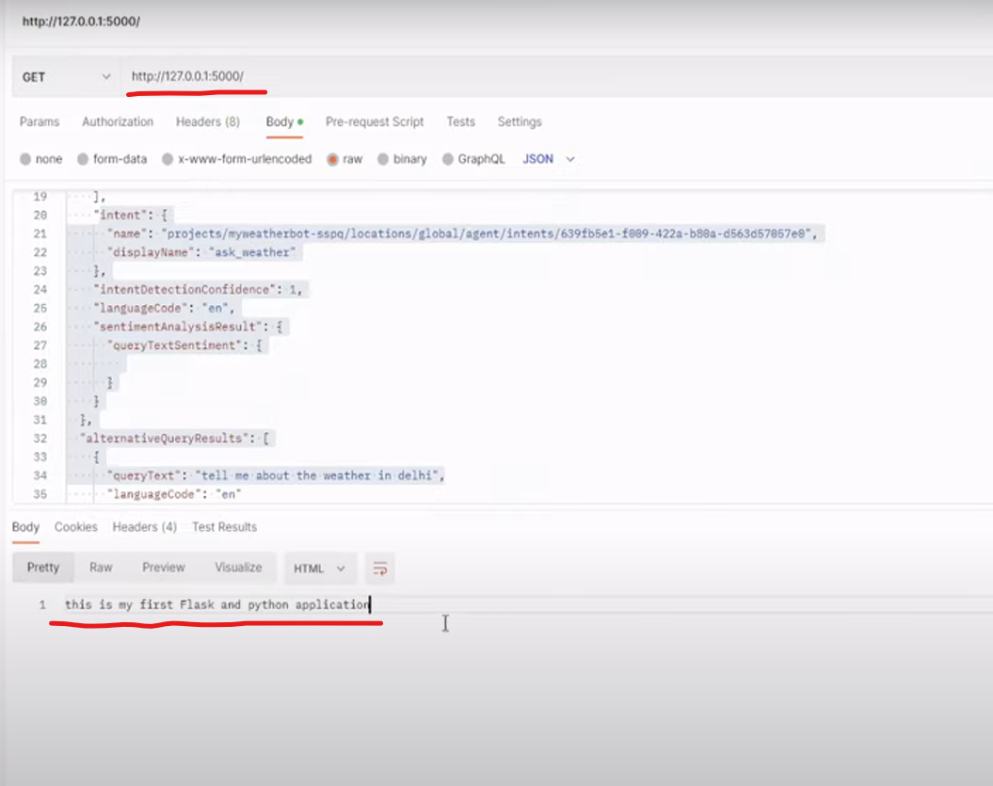

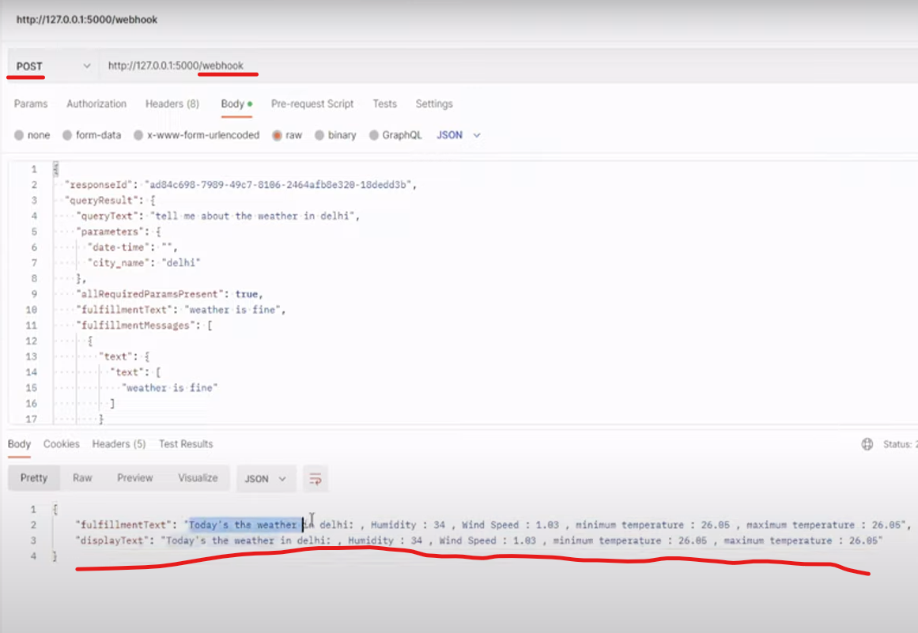

Deploy the Application in AWS

Inorder to do the deployment

Github – docker – ECR – Apprunner

We attain these steps with the help of workflow

Workflow – to create docker image, push the code to the ECR

Name , jobs ,

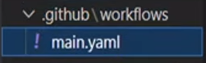

Give the name of the workflow (build and push image to ECR) we are going to build an image to the particular solution and pushing that to the ECR

Whenever any changes we do in the main branch the changes will reflect automatically image will be created and push into my ECR .

Jobs – name of the jobs , running image on which os , steps

Build image ,checkout code, install utilities, Configure AWS credentials, login to Amazon ECR, build, tag and push image to Amazon ECR.

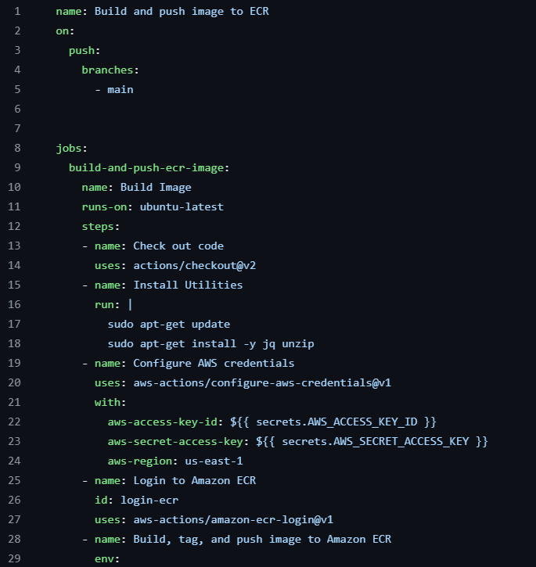

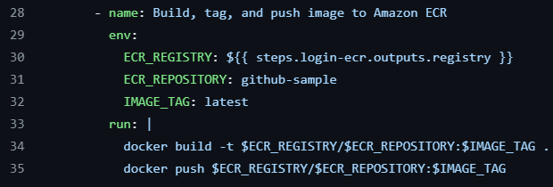

Open github

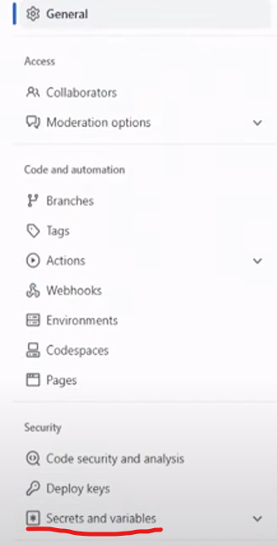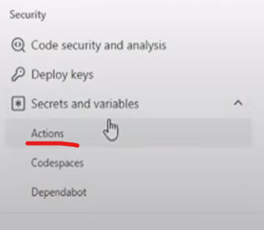

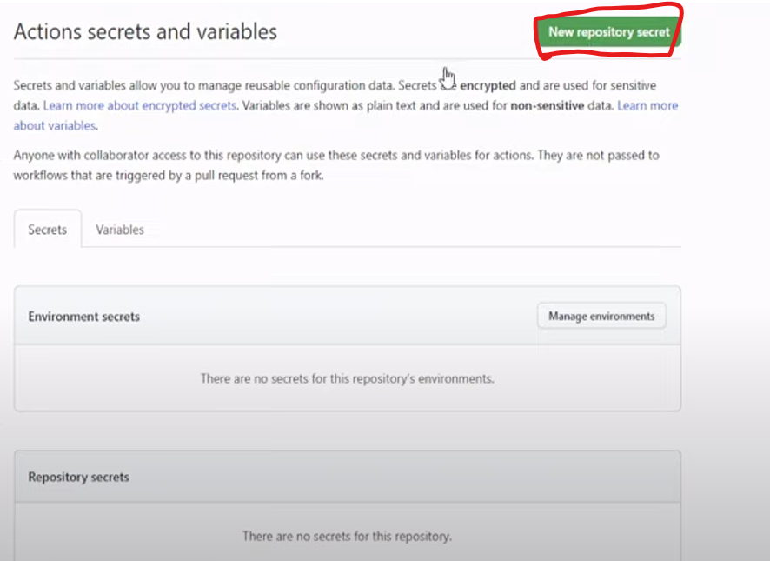

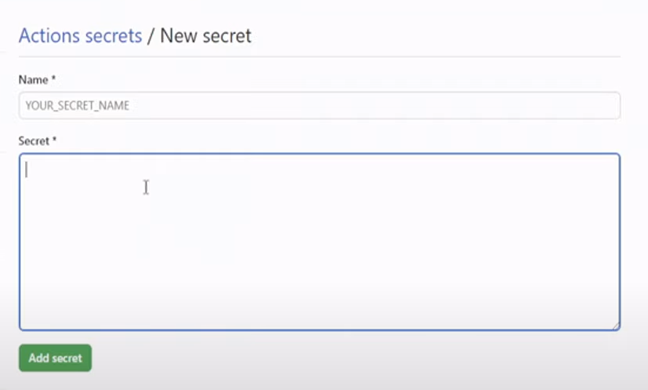

How to get the secret key (AWS access id and AWS Secret key)

AWS – Signin

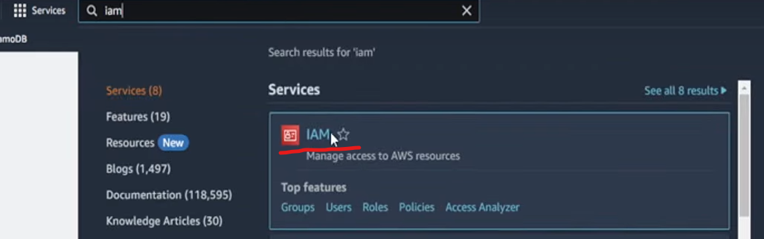

IAM – identity access management – To create a specific user and create a specific role to the user

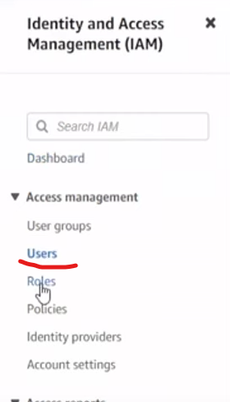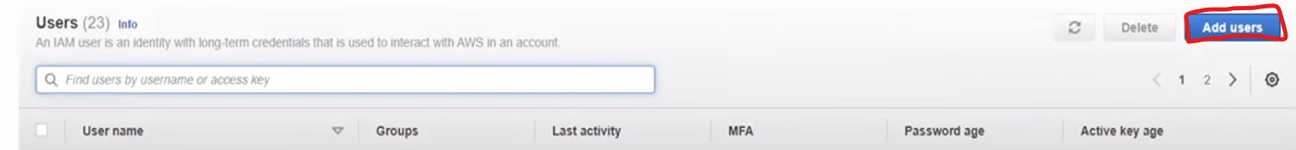

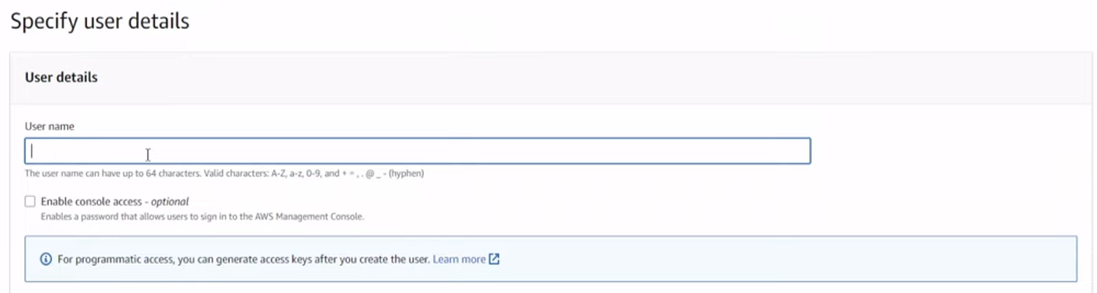

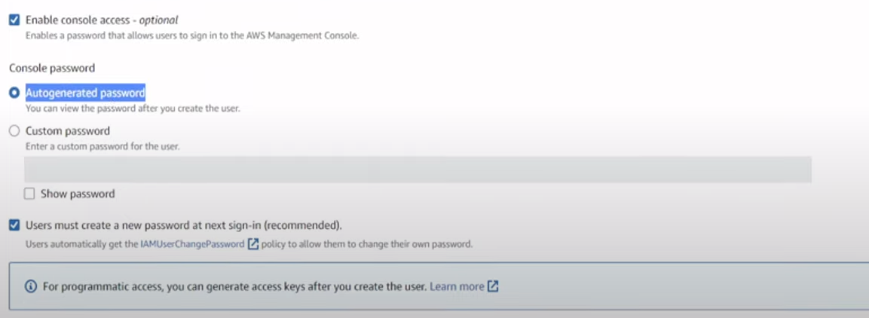

Click next

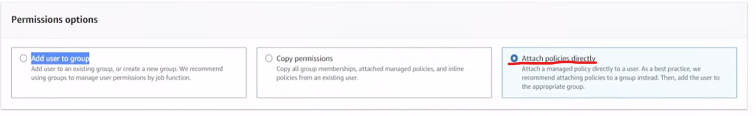

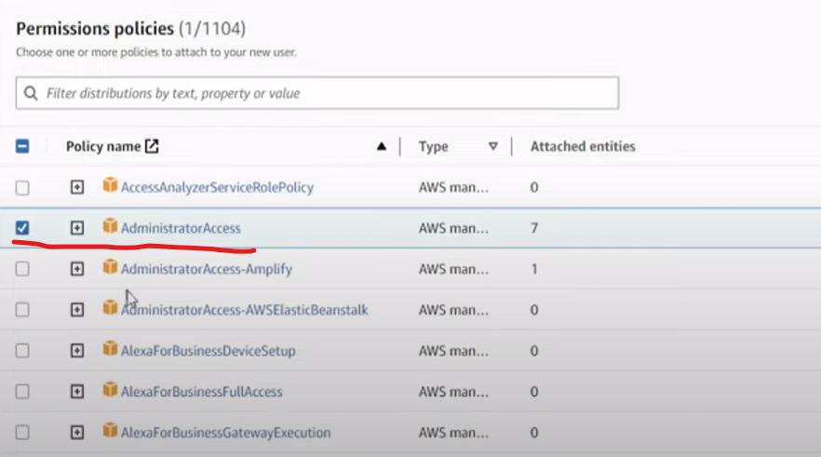

Click next

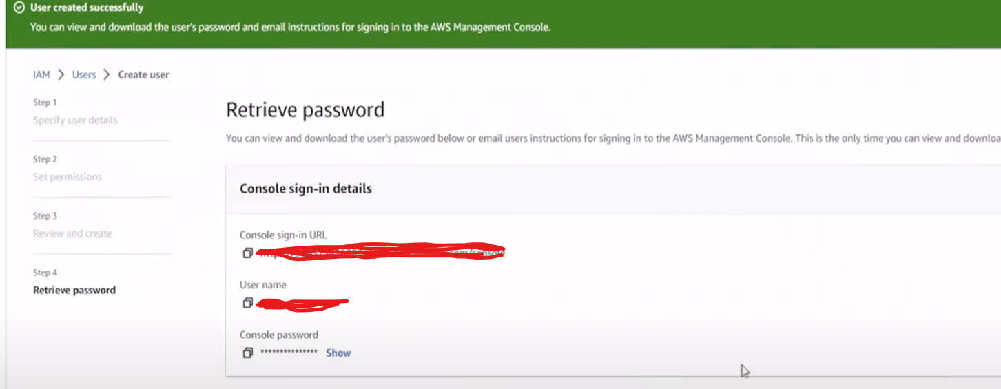

Go to the users

Search the user in the user page

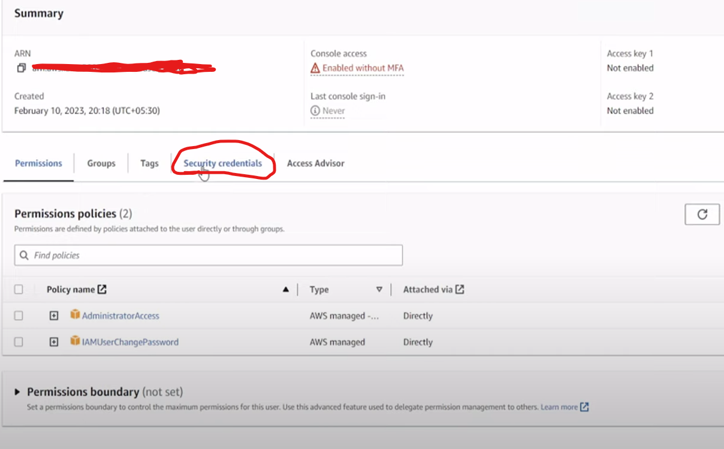

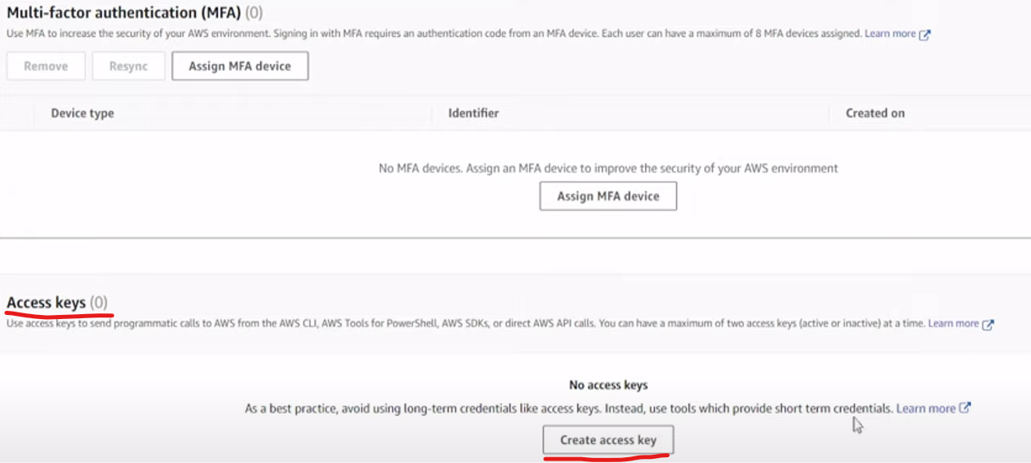

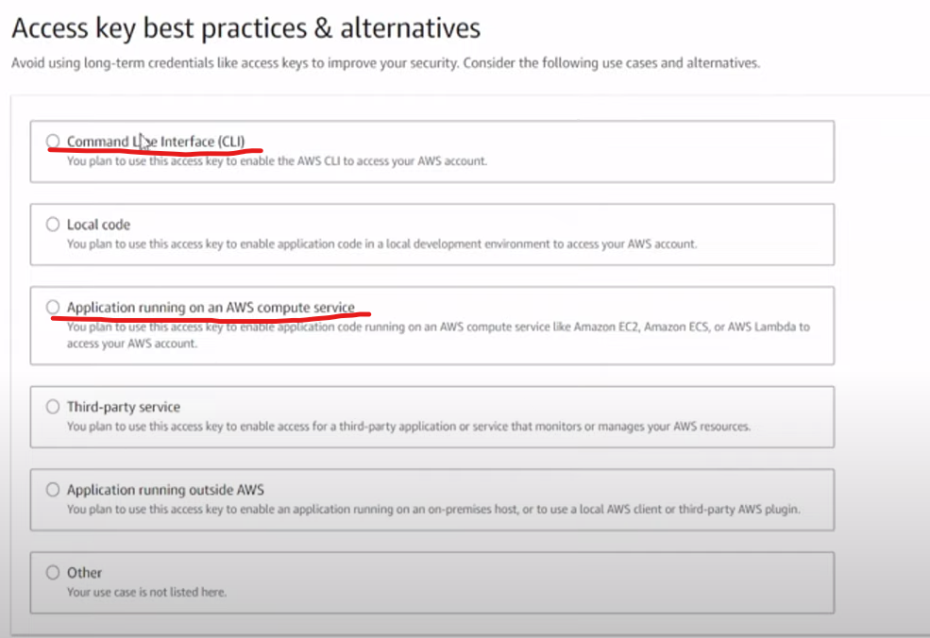

Choose any one of the options and click next

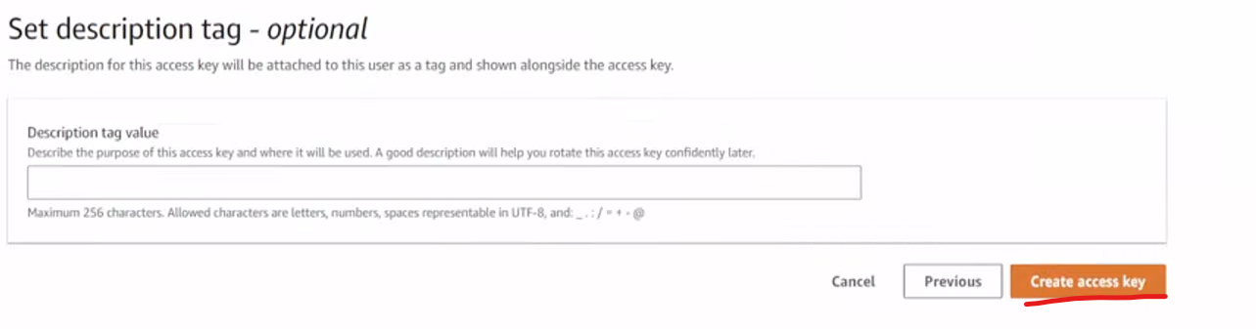

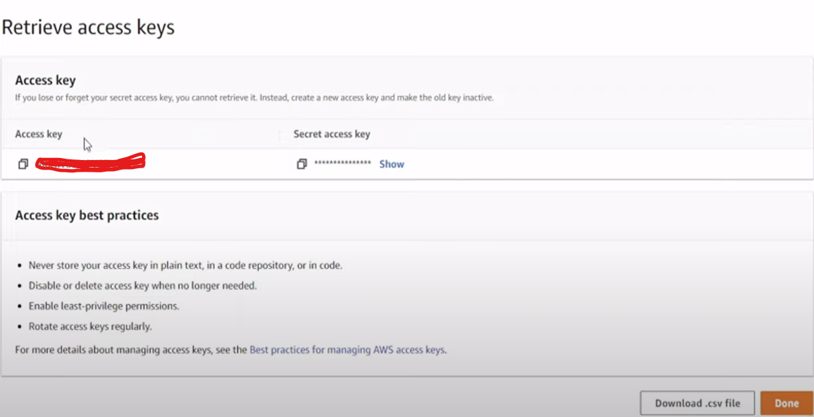

Open the github

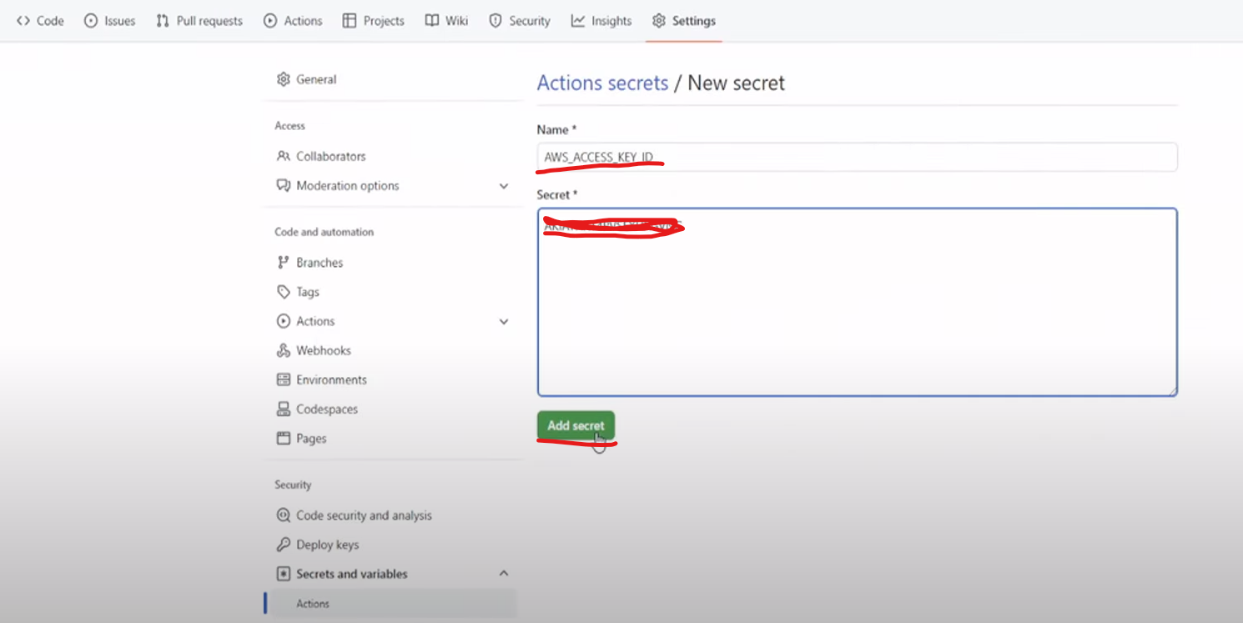

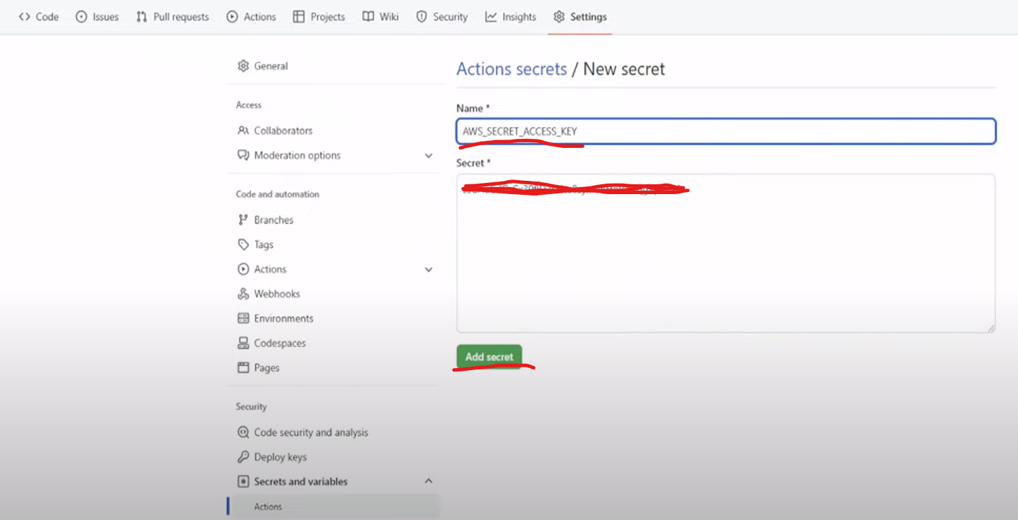

Open app.py file in the github

Comment the line no 30 and 34

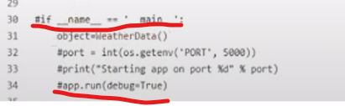

Uncomment the line number 36 and 37

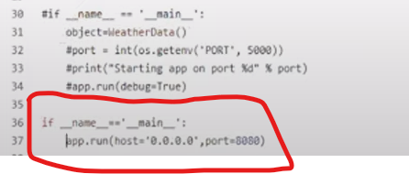

And commit the changes

Go to actions in the github

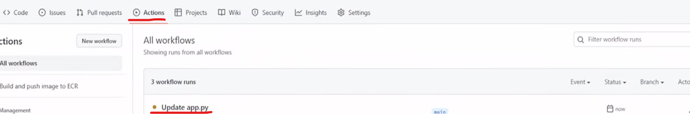

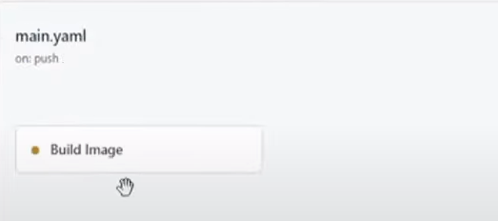

Its building the image and push into the Amazon ECR

Sometimes you will get the error on requirements.txt

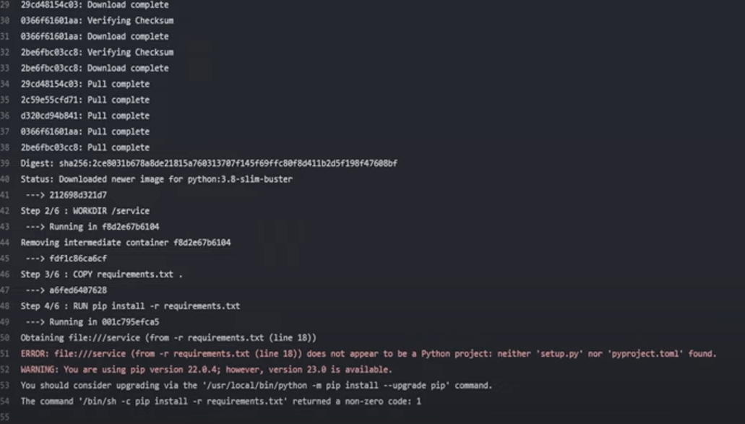

Comment or remove the -e . in requirements.txt

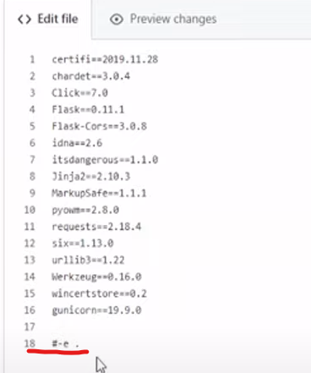

Commit changes

If you see the actions then it started to do the step-by-step process

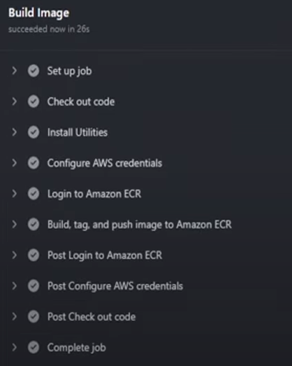

Open the AWS

Search ECR

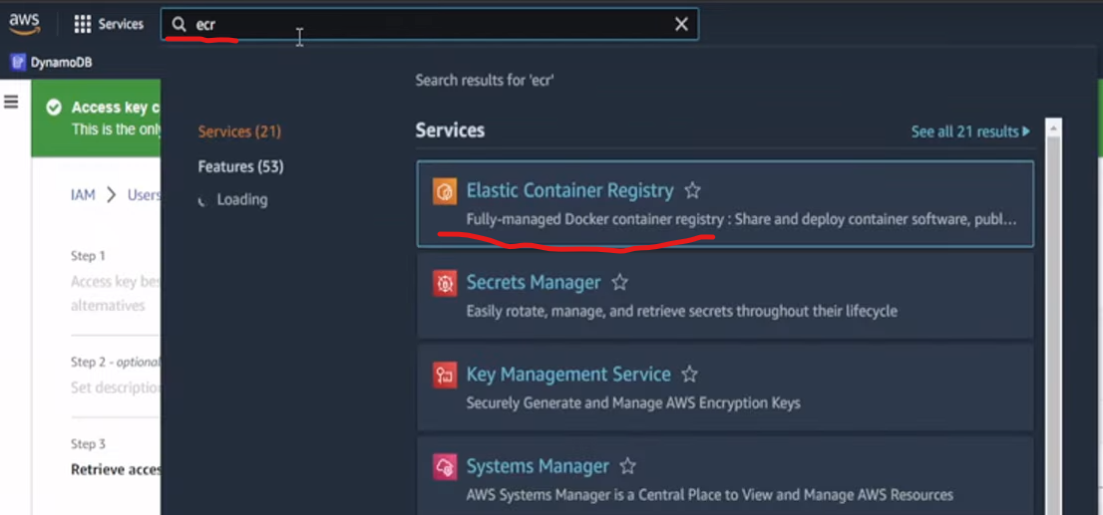

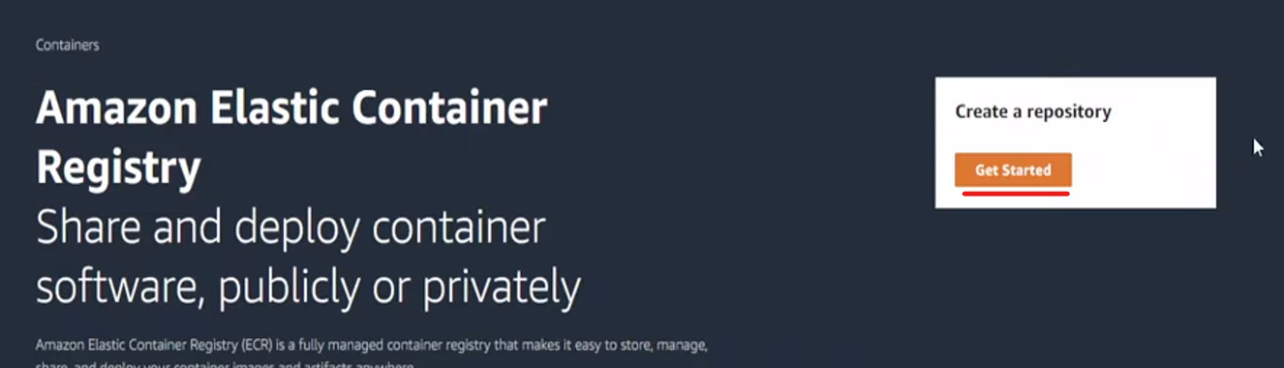

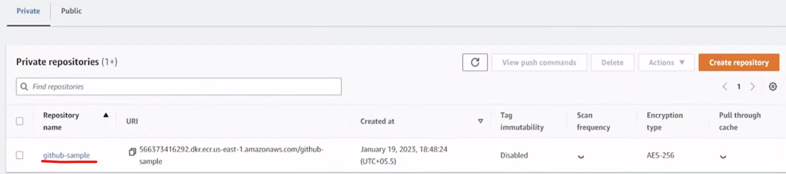

Push the image to the AWS APP RUNNER

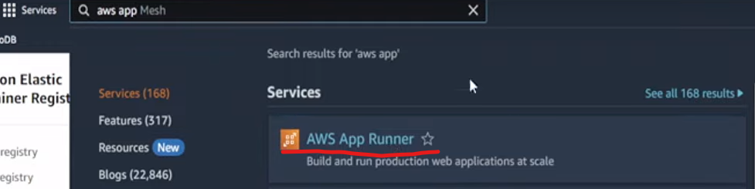



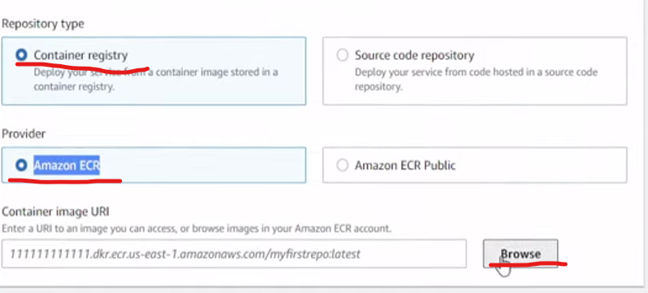

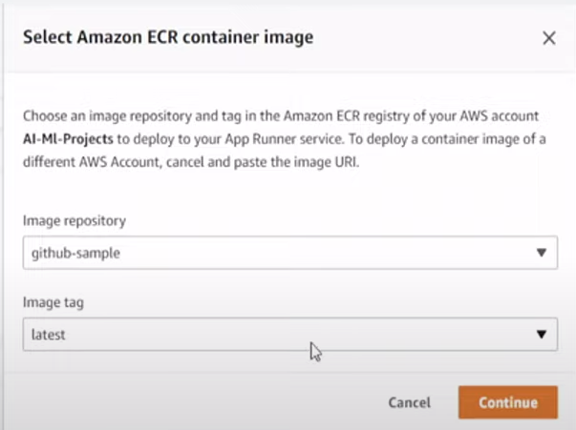

Fetch the latest image

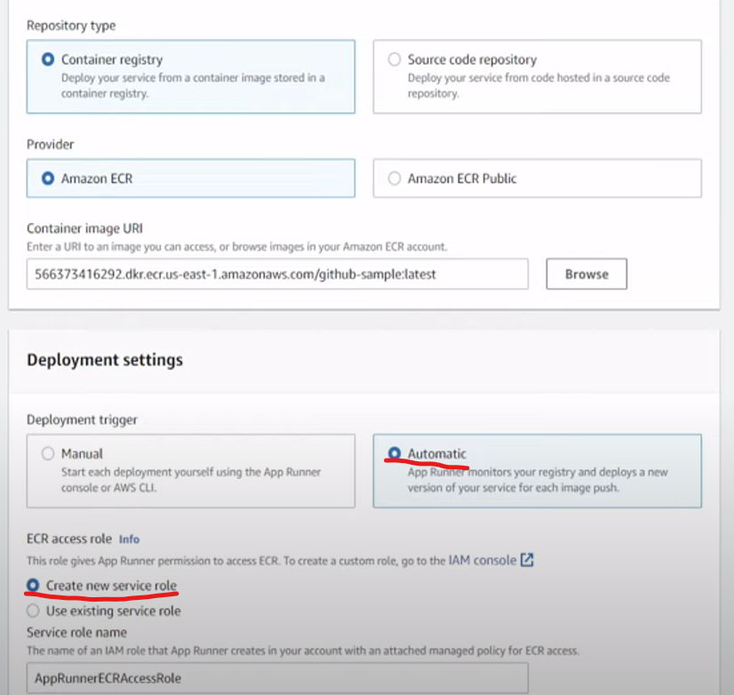

Click next

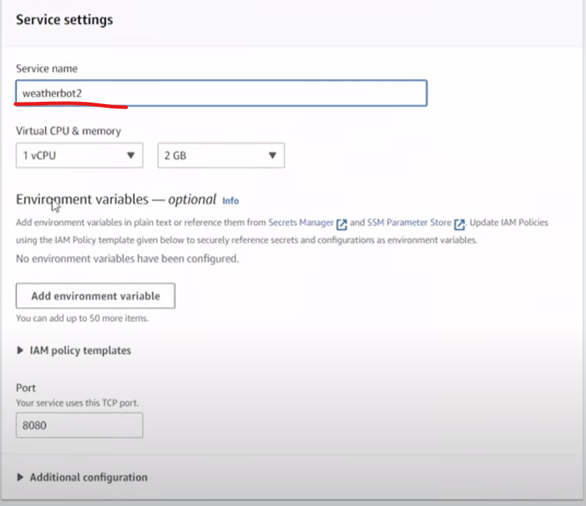

Make sure you have to mention the same port as mentioned in the app.py here.

Make other settings as default and click next

Review and crate page will be opened and finally click create and deploy

If you getting any role based error then change the existing service role instead of creating new service role.

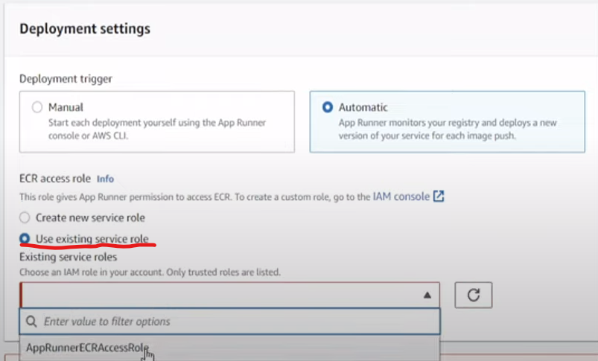

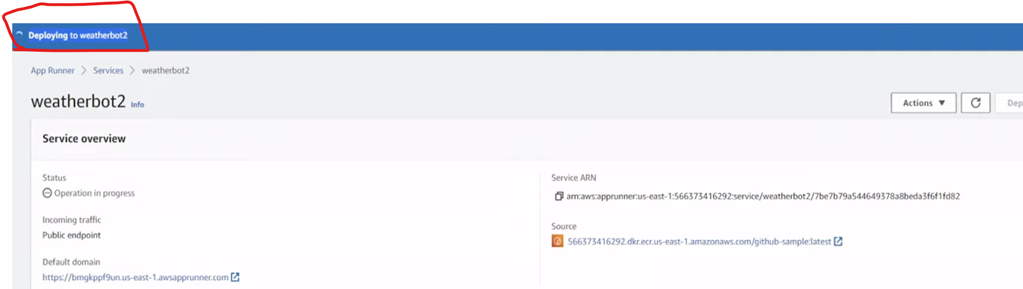

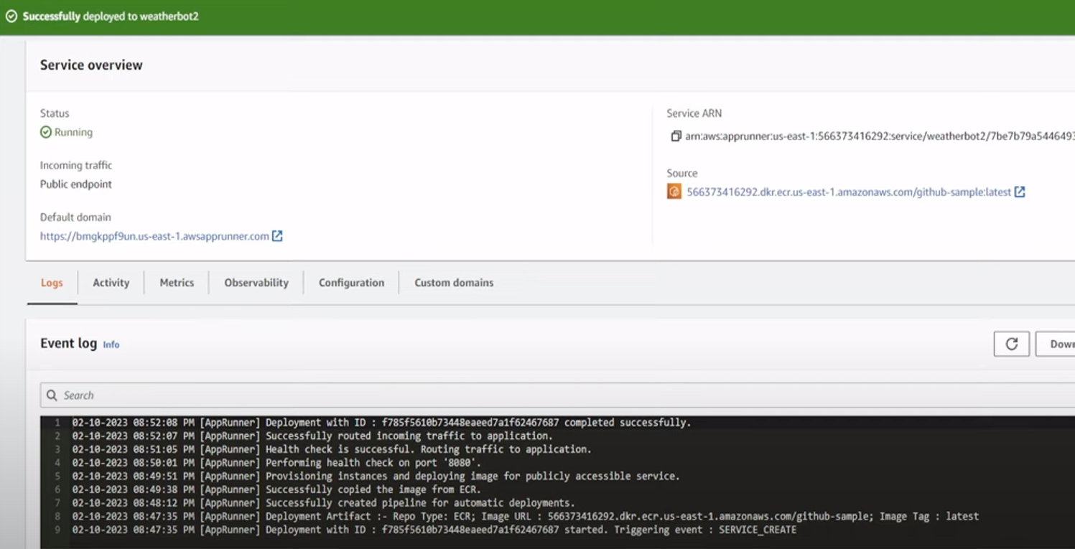

With the help of this URL we can access the application

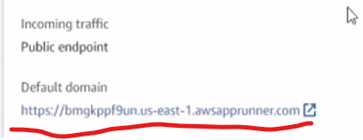

Postman

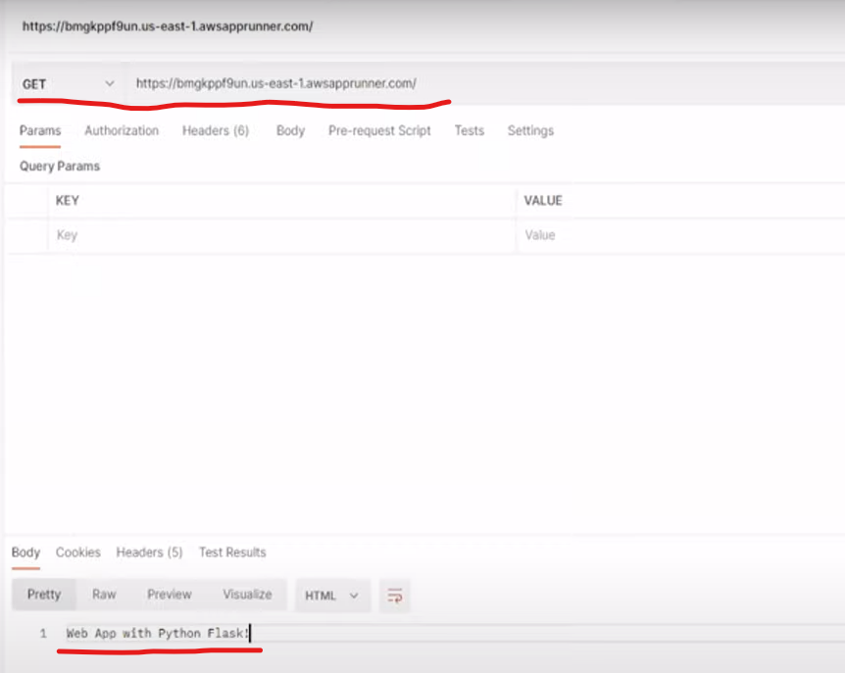

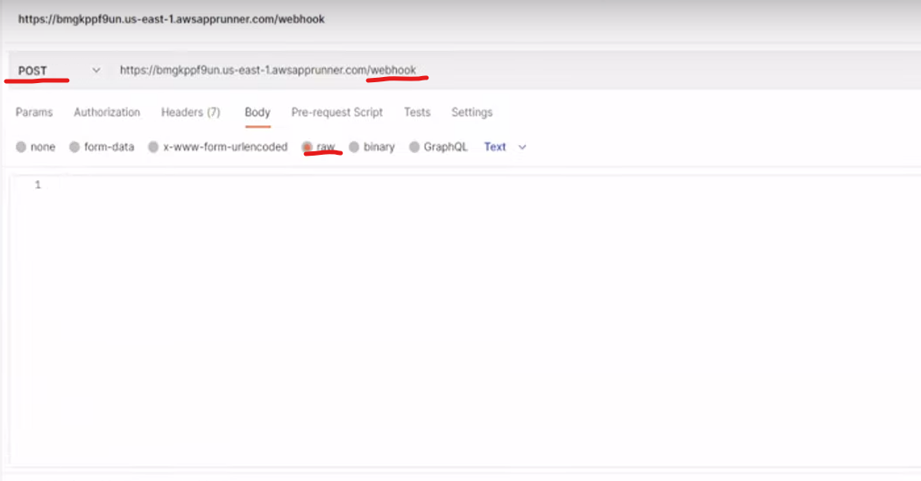

Open the google dialog flow and copy the schema

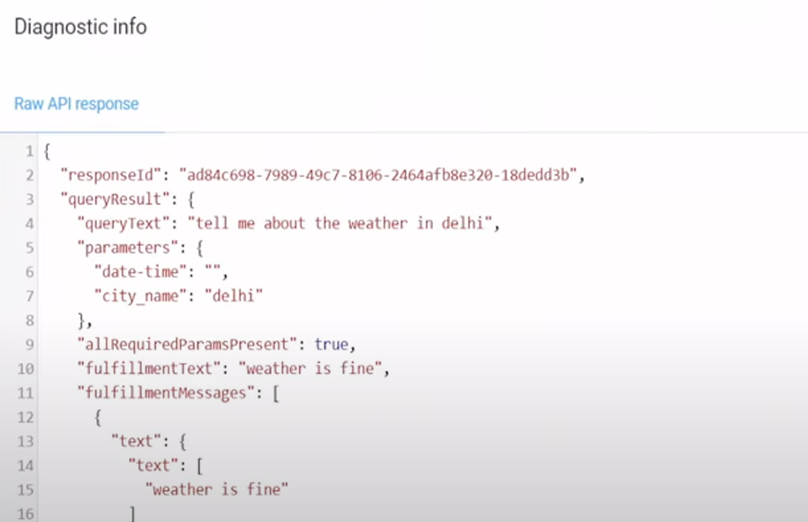

Copy all and paste inside the postman

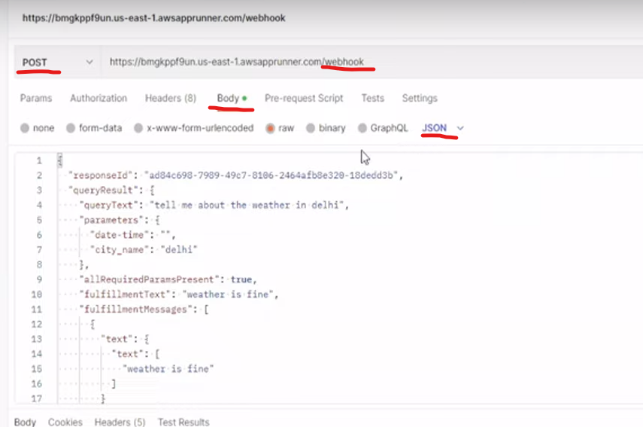

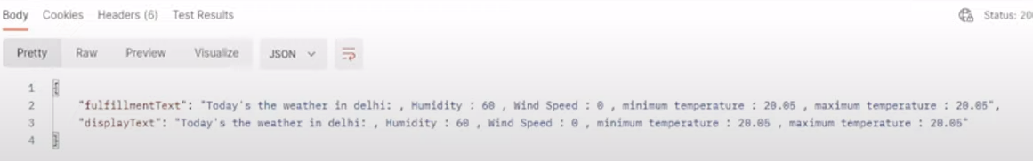

Open Google Dialogflow

Open Fulfillment

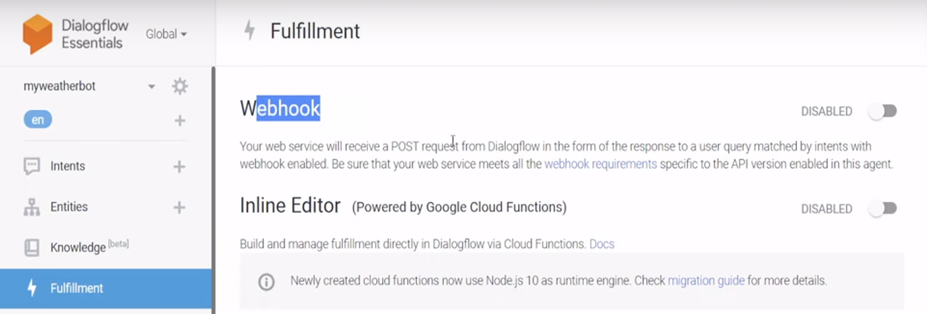

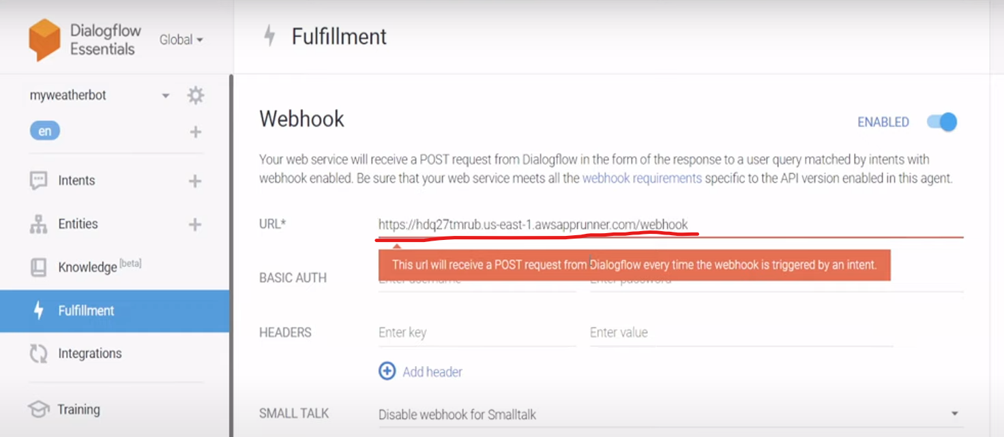

Click save

Go to intent

Open the specific intent

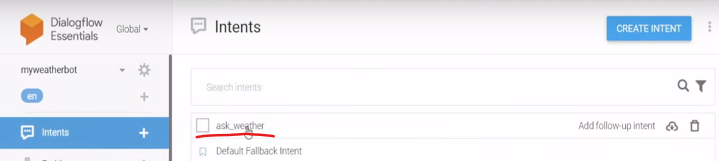

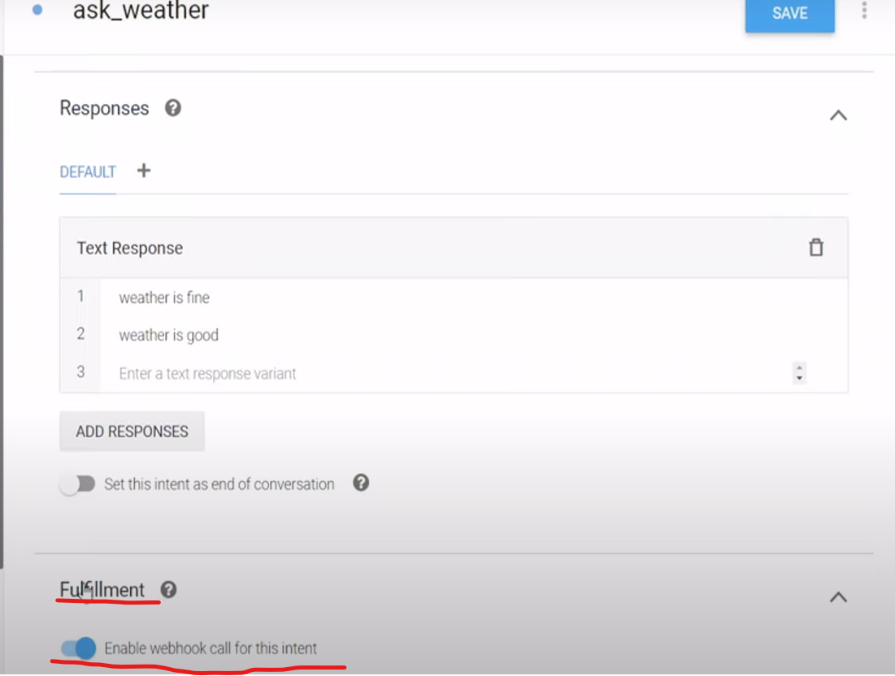

Click save

Check the app

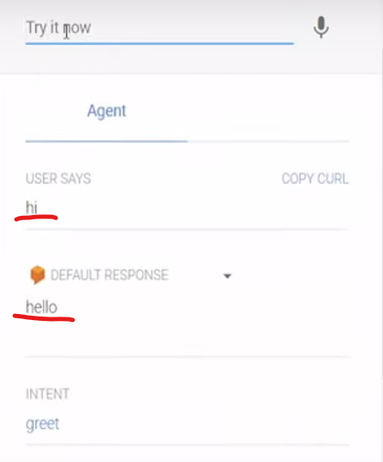

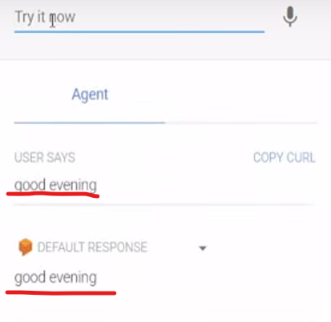

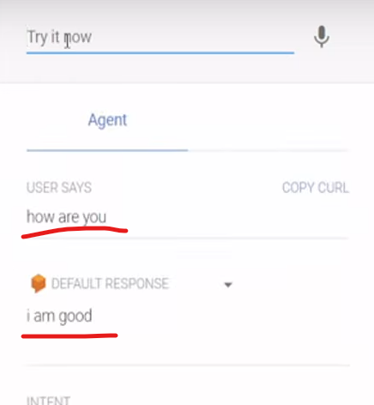

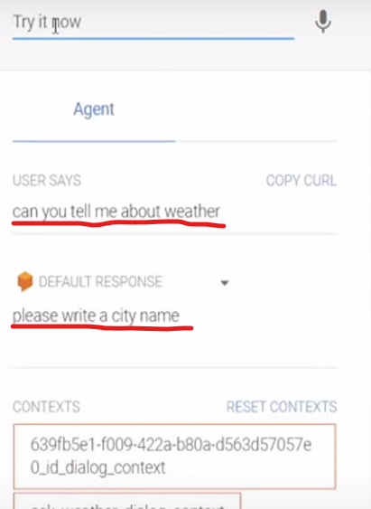

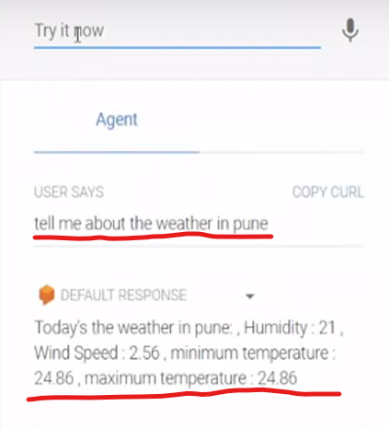

Integrate weather chatbot with Telegram

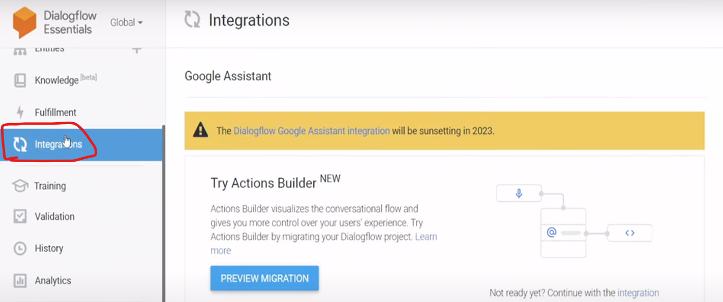

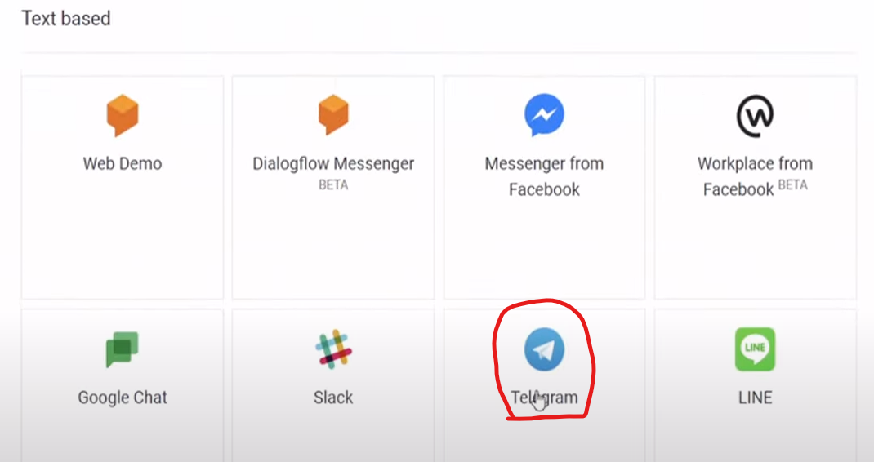

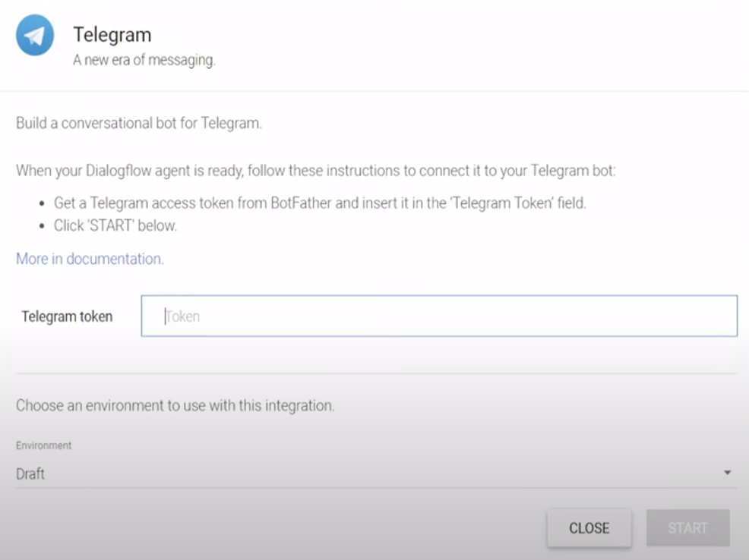

Open telegram and search bot father

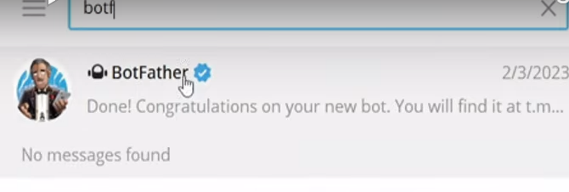

Write : /newbot

Write a name : myweatherbot

Username : “any name”

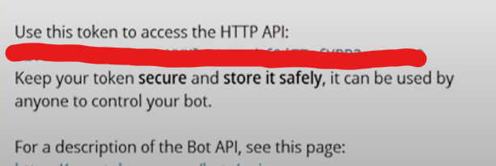

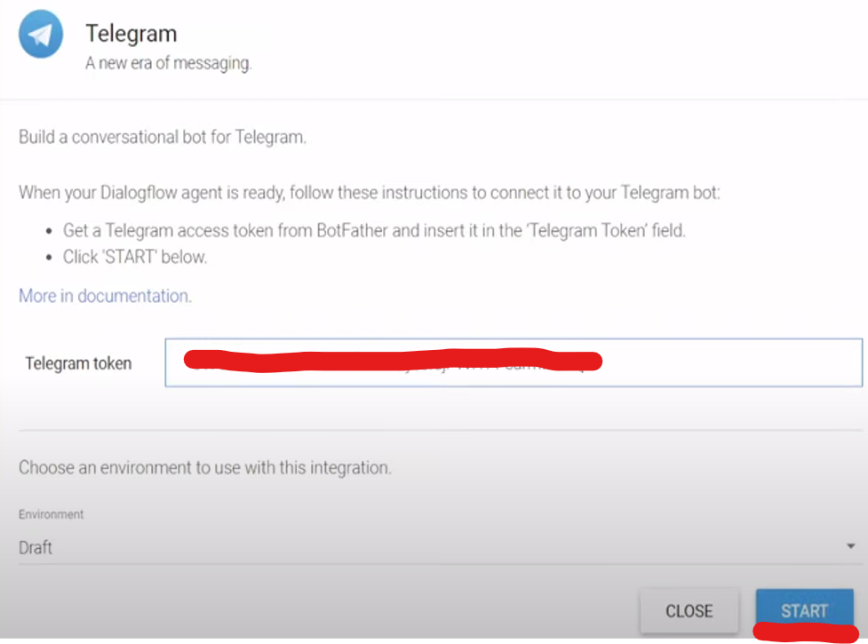

Click the telegram link of the specific user

